Senior Management Team
Monthly Meeting
10.30am on Thursday, 24 February 2022
Minutes

ATTENDING
Ian Bruce, Acting Ethical Standards Commissioner (AESC)
Karen Elder, Head of Corporate Services, (HCS)
Angela Glen, Senior Investigating Officer (SIO)
Melanie Stronach, Acting Public Appointments Manager (APAM)

IN ATTENDANCE
Katherine Lafreniere, Corporate Services Officer (CSO)

The meeting noted that the Commissioner is on a period of absence. In the interim the Scottish Parliamentary Corporate Body (SPCB) has appointed Ian Bruce as Acting Ethical Standards Commissioner (AESC) and Karen Elder as Accountable Officer (AO).

- Previous minutes
- The HCS raised how these minutes have become more publication-like and therefore need to be consistent in style and format. Senior Management Team (SMT) in agreement. As a result, the previous minutes were not approved at the meeting. Instead the meeting agreed that these would be reviewed and circulated the next day and approved via email.
Matters arising
- All actions were completed with the exception of the following, or as discussed under specific agenda headings:
- HCS and APAM to agree locations for recent and ongoing project material.
- SIO and HCS to liaise over amending dismissal taxonomy.
- HCS to finalise and submit a data protection impact assessment for recording in MSTeams.
- SIO to review standard wording regarding judicial review.
- SIO to review website wording to highlight that MSP conduct has to be in relation to their parliamentary duties to be covered by the Code.
- HCS and APAM to create and issue a staff survey to gauge morale.
- HCS to invite DPO to a future team meeting.
- HCS to arrange translating all content on ‘How to make a complaint’ web pages into BSL.
Comments
- SIO to arrange update of appendices and inclusion in investigations manual. Progress is ongoing.
- APAM and AESC to review way in which contacts are being recorded to ensure they are being measured on a like for like basis with previous years. Scheduled to be reviewed before year end stats are reported.

- Governance and providing assurance
- Stakeholder engagement
      - 28 January – AESC and Executive Director of the Standards Commission for Scotland (SCS) met with representatives from the Scottish Government (SG) to discuss support for parties to investigations involving sexual harassment complaints.
      - 31 January – APAM met with the SG Public Appointments Team (PAT) Head of Improvement & Outreach.
      - 8 February – AESC and SIO met with the Executive Director of the SCS to agree items for discussion at the next formal meeting between the SCS and the ESC.
      - 8 February – AESC met the Clerks to the Standards Procedures and Public Appointments (SPPA) Committee to discuss issues of interest to the Committee.
      - 10 February – AESC gave evidence on the Annual Report to the SPPA Committee.
      - 17 February – AESC and SIO met with SCS. Fortnightly meetings between the SCS and the whole Standards team will recommence in March 2022. Regular updates still being provided.
      - 17 February – AESC and HCS met with the SPCB to discuss the office’s governance and recommendations from the auditor’s report requiring SPCB input and/or agreement.
  - 21 February – AESC responded to the Welsh Senedd’s consultation on prospective revisions to their procedures for investigating member complaints.
- Strategic Plan
- Formal review is scheduled annually for September. This item can be removed from the standard agenda.
- Business plans – development and progress against
- Revised Code of Practice was delayed by three months in order to allow for detailed and meaningful consultation with the SG. A near final version of the Code has now been submitted to the Cabinet Secretary for Finance and the Economy. The AESC has advised that he wishes to publish the final Code prior to the end of the financial year but is happy to be flexible about the implementation date.
- Public Appointments is up to date with the exception of contacting body chairs for their views on the difference new appointees have made. This activity will resume when there is capacity. Reviews of Public Appointments Advisor (PAA) input and process is up to date but the follow up and panel education on opportunities available under the Code was not undertaken.
- The investigations manual has been updated further to include feedback from the whole standards team and the incorporation of key performance indicators (KPIs). The manual is on track to be issued to stakeholders for consultation prior to the end of the financial year.
- Formal discussions with the SPCB regarding governance are now underway and an internal auditor has been appointed. This process was delayed by the late publication of the external auditor’s report for 2020/21.
- It was agreed that, prior to the next meeting, each SMT member will update their status on the business plan tracker and note what will be carried into next year. They will also start thinking of proposals for the following year.
- Managing risk
  - Risks to the organisation are to be reviewed next month. Prior to next meeting each SMT member is to consider the risk register and identify any changes.
- Review of governance
- The HCS submitted the ESC’s governance arrangements to the SPCB in February in response to a request made to all officeholders. The AESC and HCS met the SPCB on 17 February to discuss governance and will meet the internal auditors on 24 February. The internal auditors will be asked to begin by reviewing ESC’s governance arrangements.
- The meeting discussed inviting the internal auditors to a future team meeting to introduce themselves. It was agreed that they would be invited to a monthly team meeting or, if moving quickly, that an introductory meeting would be set up with the whole team and the internal auditors.
- Monitoring performance
- Framework is still in place.
- Complaints about us
- No complaints received since last meeting.
- The AESC is to meet a complainer at the beginning of March, who complained in November 2021, to discuss his decision.
Actions
- SMT members to update their status on the business plan, note what will be carried into next year and think of proposals for the following year, for next meeting.
- SMT members to consider the risk register and identify any changes for next meeting.
- AESC and HCS to invite internal auditors to a future team meeting.

- Operating an effective complaints system
- Current complaints volume and status
Councillors/Members (Cllr/M)
- Current status of complaints received

Stage | Cases | Complaints
Councillors
Admissibility | 58 | 101
Investigation | 12 | 16
Interviewing* | 1 | 1
All Info Gathered* | 8 | 19
Draft decision | 4 | 34
Proposed report | 1 | 1
Members
Admissibility | 10 | 15
Investigation | 1 | 1

- Complaints volumes are slightly higher than they were in January/February 2021. Number of investigations is significantly higher than the same period in previous years. The number of investigations are as follows:

Month | 2021/22 |  | 2020/21
 | Cases | Complaints | Cases | Complaints
Sept | 13 | 7 | 4 | 4
Oct | 21 | 35 | 2 | 2
Nov | 23 | 39 | 0 | 0
Dec | 30 | 74 | 0 | 0
Jan | 26 | 69 | 0 | 0
Feb | 26 | 71 | 1 | 1

- To increase understanding of this trend, investigation stats will be produced for 2017/18 and 2018/19 using the ESC’s old database.
- ESC issued three reports to the SCS (all no breach reports). In one report, the SCS instructed the ESC to investigate further. In the other two, the SCS asked further questions.
- An online hearing was held on 16 February. This was the first ever hearing of a no breach report. The SIO presented and the ESC’s finding of no breach was upheld by the SCS.
MSPs
- 17cases, covering 686 complaints currently open.
- All complaints received up to 27 January have been assigned for initial assessment.
- The standards team are meeting biweekly to discuss the significant number of complaints received over the course of March and April 2021. The next meeting is scheduled for 3 March. At that time all material will have been examined and the AESC will take a view on how to progress the investigation.
- Current complaint issues
Councillors (Cllrs)
- Complaints about disrespect towards employees/public/Cllrs, including bullying and harassment, still form the majority of cases; comprising 48% of Cllr complaints. There has also been a rise in complaints relating to quasi-judicial decision making, such as planning applications, and failures to declare interest. The number of cases are as follows:

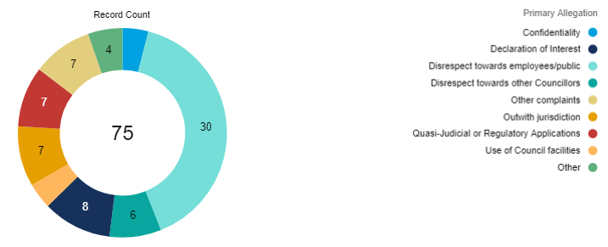
Members
- The majority of cases relate to disrespect. The number of cases are as follows:

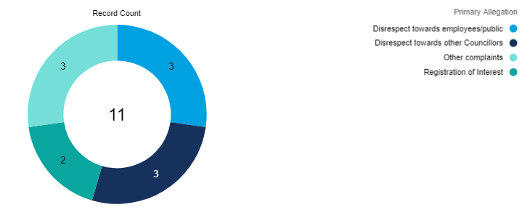
MSPs
- Complaints about the conduct of MSPs are fairly evenly distributed. The number of cases are as follows:

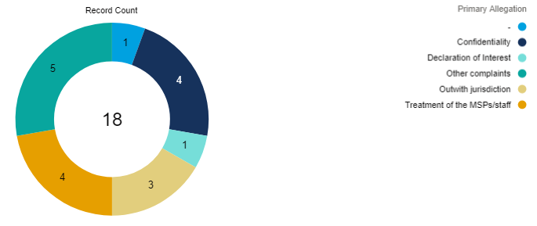
- Revising our complaint handling procedures
- The investigations manual is now in draft version five and includes KPIs. This will be sent to the SCS prior to the biannual meeting on 28 February.
- The AESC has approved wording for MSP privacy notices and template letters relating to MSP complaint investigations.
- The AESC has highlighted issues in the MSP Code and/or guidance with the Clerks to the SPPA Committee that he considers would benefit from clarification.
- The AESC has responded to an enquiry from the Presiding Officer (PO) in respect of two complaints received.
Actions
- SIO to arrange production of stats on open investigations in 2017/18 and 2018/19.

- Regulating appointments to boards
- Current appointments volume and status
- 59 new PAA allocations made to prospective rounds in current year (PY: 48). The percentages of allocations made at each level is similar to last year.
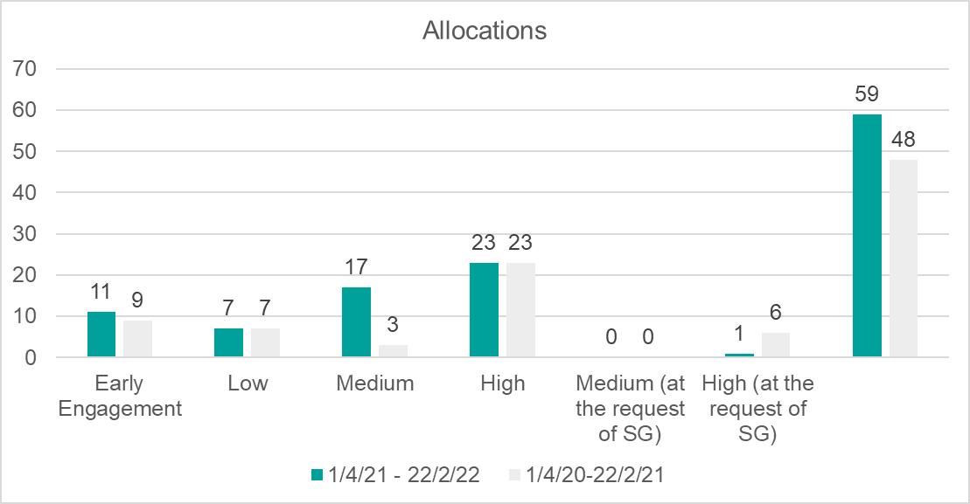

- 141 reappointments notified between 1 April 2021 and 23 February 2022 (PY: 69).
- 31 instances of non-compliance in year to date over 10 boards. For the majority of these (all but one) members were not given 13 weeks’ notice of their reappointment but were verbally kept informed of progress.
- Current appointment issues
- Two good practice case studies identified but still lacking capacity to complete these.
- The ESC is awaiting changes to SG policy on in person interviews following announcement on ‘learning to live’ with Covid.
- The ESC is waiting to hear how the SG’s new applicant tracking system is being received by applicants. The AESC raised concerns with the SG regarding the changes this makes to the data being collected but has not yet received a response.
- There were 506 contacts and enquiries between 1 April 2021 to 22 February 2022 (same period 2020/21: 684). It was identified at the January SMT meeting that many enquiries made during 2021/22 were not being recorded on a like for like basis with previous years. The AESC is to review enquiries from 2021/22 before the year end stats are reported.

Enquiry about/for | No. | Report about | No.
Advice on the Code | 134 | End of round | 32
Advice on good practice | 31 | Concern about appt round | 55
General work of office | 10 | Update on a round | 30
Other | 44 | Report good practice | 46
Exceptional circumstances | 36 | Other | 84
Additional appointments | 7 | Report non-compliance | 4
Extension request – NB | 13
Emergency appointment | 3
Panel membership | 5
Planning | 2
Succession planning | 2
Use of recruitment consultants | 3
General exception for applicant summaries | 1
TOTALS | 255 |  | 251
28 both enquiry and report

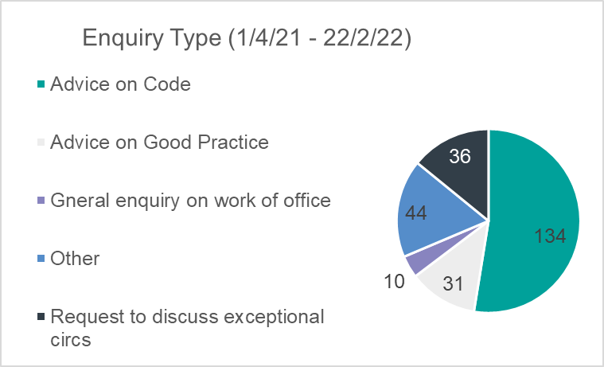

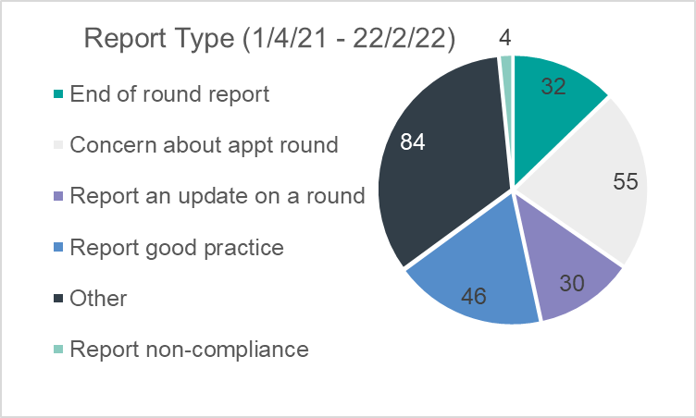

- Revising the Code of Practice
- Final draft of the Code has been sent to the Cabinet Secretary for Finance and Economy.
- The initial plan for implementation has been received from the SG and is to be discussed further. Positive discussions have taken place with the SG so far and the implementation plan shows a very strong commitment to training.
- Providing guidance and support
- Four reports of non-compliance have been received to date. All have been addressed.
- Good practice continues to be reported in a number of instances, particularly in NHS rounds.

- Operational matters
- Staff management and training
  - Training
    - The SIO received a proposal from Diversity Scotland to provide training on topics relating to diversity, equality and inclusivity. The APAM also received offers from some PAAs to provide this training. These PAAs are consultants in their own right and have presented these training programs to other bodies. The meeting discussed how to roll out this training. It was agreed that Diversity Scotland should deliver training on trans rights, gender identity and sexual orientation. The SIO will request references from Diversity Scotland. It was also agreed that the PAAs might be approached at a later date to provide training on other protected characteristics.
    - The SIO received a proposal from Brodies for bespoke training on sexual harassment complaints handling. The meeting agreed to proceed with this training for the standards team.
    - The HCS will review the decision to carry out first aid training for the Corporate Services Team (CST) given the current occupation rates in the office.
    - The HCS will arrange for DSE and mental health awareness training.
  - Workforce planning
    - The APAM’s initial workforce planning identified the requirement for four public appointments posts to handle workload. There is a risk that the introduction of the revised Code of Practice will not be supported fully if additional resource is not made available.
    - For the next meeting, each SMT member will consider the amount of resource required to complete activities in their remit, with the end goal of identifying exactly how much resource is needed to meet the ESC’s objectives.
    - It was agreed that at home display screen equipment (DSE) assessment requests will be issued in March 2022. There will be a reminder to complete these at the next team meeting.
- Finance
  - Monthly spend analysis has been circulated.
  - The HCS will circulate the scheme of delegation and highlight anything that might change.
- Information governance
- IT and cyber-security issues
  - The meeting discussed that, due to the current situation in Ukraine, there is an increased risk of a cyber-attack. The CSO will send a reminder to the team to ensure everyone is regularly logging out of the remote desktop and forcing through updates on laptops. The CSO will also contact IT support providers to ensure that all software is being kept up to date. The HCS suggested that final case decisions are stored on the server as well as the online case management system (CMS) to ensure documents are protected. The SIO will share this with the standards team.
  - There has been an increase in how often the ESC is asked to send or receive large files. The HCS will set up a WeTransfer account which will allow a link to a password protected large file to be sent, accessed and downloaded. The file will be deleted after 7 days.
  - The ESC’s Teams messages are now deleted after 28 days. Complaints on the ESC website are deleted after six months and accounts are deleted after 28 days of inactivity.
  - The CST has begun an update on the ESC’s website. The website map is updated and a project plan is being created.
- Records management
  - New policy and file plan have been sent out for staff consultation. Deadline for comments is 10 March.
  - Work has started on drafting the updated Records Management Plan (RMP), on track to be submitted in the spring.
- Data protection and Freedom of Information (FOI) matters
  - ESC has received two FOI and one subject access request (SAR) since the last SMT meeting. Two responses are outstanding. A two month extension has been granted for the SAR, due to the volume of material involved. Once all the material has been gathered, staff may be asked to assist with its review and redaction.
  - Privacy notices are now close to finalisation and feedback from the clerks to the SPPA committee has been received.
- Impact of Covid-19 and return to office
- Update on return to Thistle House
  - Building has now reopened. The requirement for physical distancing may end on 21 March. Formal SG guidance, and how SLAB will choose to implement this guidance, is not yet available. An assessment on accommodation requirements will be carried out by the ESC before August.
- Consideration of latest SG Trade Union Covid Protocol
  - This protocol is already out of date. The ESC was already following most steps relating to hybrid working included in the protocol. The meeting discussed the need to be clear about what onsite duties are and who is maintaining the office while also making sure to support those working from home.
- Implementing and managing hybrid working (see above)
- Annual report and accounts
- Waiting for draft audit plan from Deloitte, the ESC’s external auditor.
- The AESC wrote to the Auditor General raising concerns and has received a response.
- Consultations received
- No consultations were received and none are outstanding.
- Items for Team Meeting
- Reminder to complete at home DSE assessments
- Reminder of the Domestic Abuse Policy
- Miscellaneous
  - Dates for future SMT meetings
    - It was agreed that SMT meetings will take place on the last Thursday of each month in the next financial year.
Actions
- SIO to request references from Diversity Scotland and arrange training session.
- SIO to progress training on sexual harassment complaints handling with Brodies.
- HCS to review decision to carry out first aid training for CST.
- HCS to arrange for DSE & mental health awareness training.
- SMT members to consider workforce requirements for their function for next meeting.
- HCS to issue DSE assessments.
- HCS to circulate the scheme of delegation and highlight anything that might change.
- CSO to send a reminder to the team to regularly log out of remote desktop and force through updates on laptops.
- CSO to contact IT support providers to ensure all software is being kept up to date.
- SIO to ask standards team to save final decisions on the server as well as the CMS.
- HCS to set up WeTransfer account.

- AOB

- Next meeting
- 10.30am on Thursday, 31 March 2022.

The graph does not include cases at ‘Interviewing’ or ‘All Info Gathered’ stages due to an error which will be corrected for future graphs of this type. Please note that numbers of complaints about breach of confidentiality or use of Council facilities is not shown due there being less than 3 complaints in each category.
The allegation described as ‘-‘ covers a case file that was opened by mistake during complaint logging process. This has been subsequently corrected and, to confirm, there are 17 MSP complaints rather than 18 in this reporting month.

