Senior Management Team
Monthly Meeting
10.30am on Thursday, 26 May 2022
Minutes

ATTENDING
Ian Bruce, Acting Ethical Standards Commissioner (AESC)
Karen Elder, Head of Corporate Services, (HCS)
Angela Glen, Senior Investigating Officer (SIO)

IN ATTENDANCE
Katherine Lafreniere, Corporate Services Officer (CSO)

APOLOGIES
Melanie Stronach, Acting Public Appointments Manager (APAM)

The meeting noted that the Commissioner is on a period of absence. In the interim the Scottish Parliamentary Corporate Body (SPCB) has appointed Ian Bruce as Acting Ethical Standards Commissioner (AESC) and Karen Elder as Accountable Officer (AO).

- Previous minutes
- The minutes of the previous meeting are agreed.
Matters arising
- All actions were completed with the exception of the following, or as discussed under specific agenda headings:
- HCS to arrange mental health awareness training.
- HCS to investigate offer to pay for leave.
- AESC and APAM to consider request for Easy Read version of the Code of Practice.
Comments:
- SIO to review standard wording regarding judicial review. Draft wording is to be shared with the Standards Commission for Scotland (SCS) for feedback.
- HCS to finalise and submit a data protection impact assessment (DPIA) for recording in MSTeams. Recording in MSTeams has now been used and the user instructions and privacy notice have been developed. Instructions to be updated to include sharing recordings via WeTransfer and the DPIA will then be sent to the Data Protection Officer (DPO) along with the WeTransfer DPIA.
- SIO to identify date for Diversity training and agree the content. Awaiting availability from everyone attending the training as well as discussion regarding having more than one session.
- HCS to arrange a date for entire team to attend risk management training. HCS has agreed for internal auditors to provide this training. Introductory session planned for 6 July 2022. HCS has also requested date for a half-day session.
- HCS to arrange a date for DPO to attend team meeting and provide brief training on redaction. Awaiting availability of DPO.
- SIO to consider amending interview procedures. Pending discussion with Standards team on 31 May.

- Governance and providing assurance
- Stakeholder engagement
- 29 April – AESC, SIO and Standards team met with the Standards Commission for Scotland to discuss issues of mutual interest.
- 29 April – AESC and the Scottish Government (SG) Public Appointments Team (PAT) ran a presentation on public appointments for the Officers Association Scotland.
- 29 April – SIO attended the Society of Local Authority Lawyers and Administrators in Scotland (SOLAR) with the SCS on revising the 2021 Code Guidance.
- 9 May – AESC gave an interview about hybrid working and meetings to an organisation that is developing good practice guidance on this topic.
- 12 May – AESC and APAM met with representatives of the Victoria State Government of Australia to provide information on good practice in securing more diverse boards.
- 12 May – AESC met with the Clerks to the Standards Procedures and Public Appointments (SPPA) Committee with a view to assisting with the Committee’s forward business planning.
- 13 May – AESC, SIO and Standards team met with the SCS for their fortnightly meeting.
- 16 May – AESC met with a SG representative to discuss support for those associated with sexual harassment complaints.
- 23 May – HCS participated in a hybrid working research project for Birkbeck College.
- 24 May – AESC met with leader of a working group to improve board diversity in England and Wales to provide information on good practice in securing more diverse boards.
- 24 May – HCS attended a Civil Service Pensions conference.
- 25 May – AESC and the Executive Director of the SCS attended and presented at a new board member induction event run by the SG.
- Business plans
- Proposals for 2022-23 and 2023-24
  - Biennial business plans for 2022-2024 have been approved. Some ISA260 actions may be removed at end of 2023/24. Individual SMT members will now prepare plans for each function and cascade actions to individuals.
- Managing risk
- Review risk register
  - The meeting discussed the risks associated with the new business plan and the HCS will prepare a new risk register for 2022/23. It was agreed that there were no significant changes to current strategic risks, with workforce resourcing remaining the most critical. Risks associated with key business plan actions were identified but will only arise when these actions are closer to being implemented.

- Complaints about us (CAU)
- No complaints outstanding following last meeting
- Complaints received since last meeting
  - One stage one complaint received. This related to the duration of time between acceptance for investigation and reporting.
- Outcomes
  - SIO had a discussion with the complainer and followed up in writing with a formal written apology for the delay and explanation of the reasons for delay and steps taken to reduce opportunities for delay in the future. Closed at stage one.
- Time taken to close
  - Six working days
- Time taken for tasks
  - Three and a half hours
- The meeting discussed the need to update the CAU database and ensure all closed complaints are marked as closed. Agreed that a field will be added in the database for the time taken to complete at stage one and stage two.
Actions
- HCS to prepare a new risk register for 2022/23.
- SMT members to prepare action plans for their team based on the biennial business plan.
- AESC and SIO to update CAU database and include field for time taken.

- Operating an effective complaints system
- Current complaints volume and status
Councillors/Members (Cllr/M)
- Current status of complaints received

Stage | Cases | Complaints
Councillors
Admissibility | 61 | 100
Investigation | 15 | 19
Interviewing | 1 | 1
All Info Gathered | 5 | 12
Draft decision | 1 | 3
Proposed report | 1 | 1
Members
Admissibility | 7 | 11
Investigation | 4 | 6
Draft decision | 1 | 1

- ESC issued one report to the SCS in the period 28 April to 26 May. This was a non-breach report.
- The AESC will present at in person hearings on 1 June and 7 June and the SIO will present at an in person hearing on 15 June. These hearings are all on non-breach reports.
- All complaints have been assigned up to the end of November 2021.

MSPs
- 19 cases, covering 749 complaints currently open.
- All complaints received up to the end of April 2022 have been assigned for initial assessment.
- The standards team continue to meet biweekly to discuss the significant number of complaints received over the course of March and April 2021. Further legal advice to inform next steps has been commissioned. The next meeting is scheduled for 9 June. AESC thanked CSO and paralegal for assistance drafting a number of letters to complainers.
- Current complaint issues
Councillors (Cllrs)
- Complaints about disrespect towards employees/public/Cllrs, including bullying and harassment, still form the majority of cases, followed by complaints about failures to declare interest and complaints about quasi-judicial decision making, such as planning applications. The number of cases is as follows:

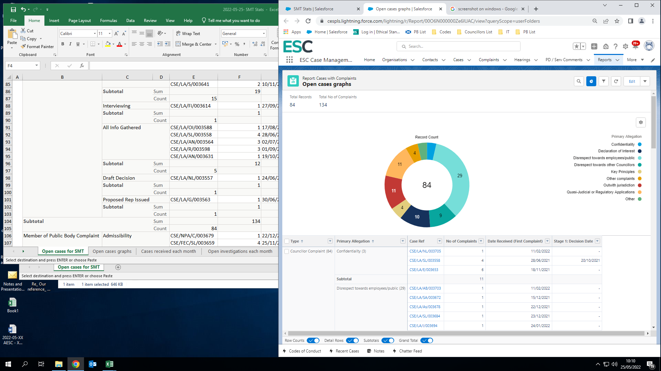

Members (Ms)
- The majority of complaints also relate to disrespect. The number of cases is as follows:

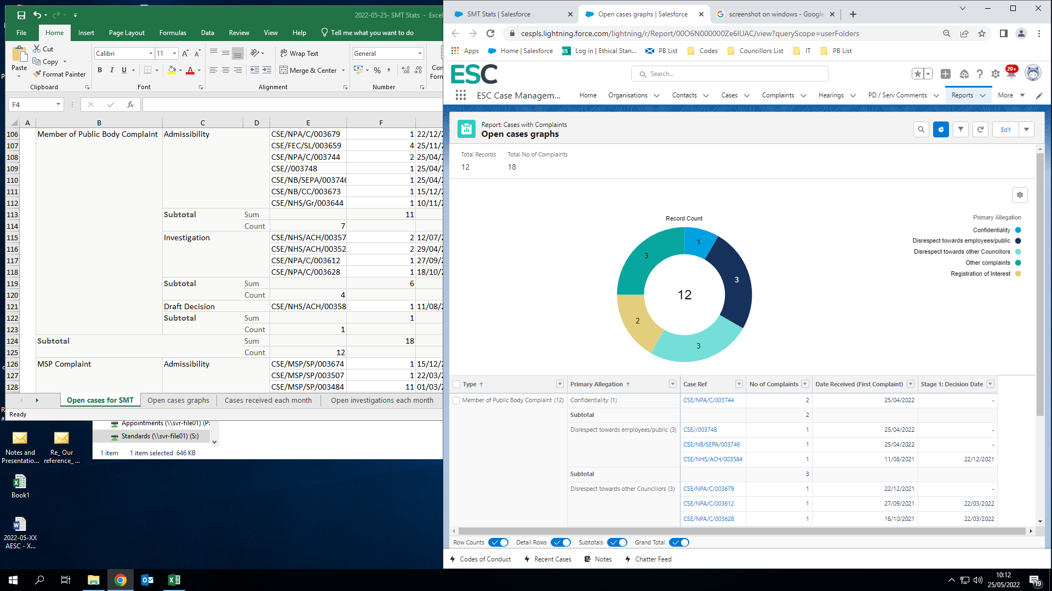

MSPs
- The number of cases is as follows:
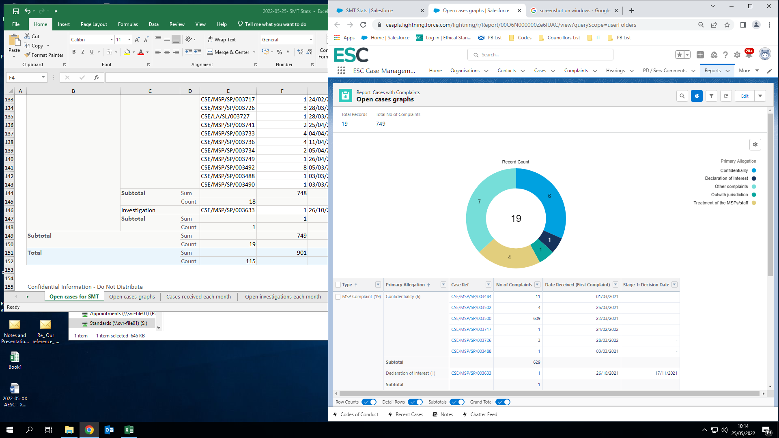

- Revising our complaint handling procedures
- Revised draft template reports sent to the SCS for input and a trial run of the revised template has already been sent to the SCS.
- A new suite of MSP template letters have been prepared by an Investigating Officer (IO) and are now with the rest of the standards team for consideration. SIO thanked the IO for preparing these letters.
- The standards team will discuss possible changes to evidence gathering and interview recording at a meeting on 31 May.
- The investigations manual is in draft version six. This version is currently with the SCS and the SOLAR for comment. The manual will likely be ready for public consultation in June.

- Regulating appointments to boards
- Current appointments volume and status
- Five new public appointments advisor (PAA) allocations have been made in current financial year so far (previous year: 24).
- One of the new allocations is for the full committee for the Scottish Local Authorities Remuneration Committee which was stood down in 2013 and this is the first activity since.

- 11 reappointments notified in financial year (1 April 2022 – 19 May 2022) (PY: 18). One instance of non-compliance where the member did not receive formal notification within 13 weeks of their reappointment, although they had been kept informed verbally. Three reappointments (for one body) have been published on the SG website, but no notification as to whether these are compliant or not has been received yet.
- Current appointment issues
- There were 90 contacts and enquiries between 1 April 2022 and 19 May 2022 (PY: 98).

Enquiry about/for | No. on 2013 Code | No. on 2022 Code | Report about | No. on 2013 Code | No. on 2022 Code
Advice on the Code | 17 | 2 | End of round | 7 | 0
Advice on good practice | 8 | 1 | Concern about appt round | 5 | 0
General work of office | 5 | 0 | Report an update on a round | 15 | 0
Other | 5 | 2 | Report good practice | 6 | 1
Exceptional circumstances | 7 | 0 | Other | 6 | 1
Additional appointments | 2 | 0 | Report non-compliance | 2 | 0
Extension request – NB | 5 | 0
Emergency appointment | 0 | 0
Panel membership | 0 | 0
Planning | 0 | 0
Succession planning | 0 | 0
Use of recruitment consultants | 0 | 0
General exception for applicant summaries | 0 | 0
TOTALS | 42 | 5 |  | 41 | 2

- Revising the Code of Practice
- Revised Code of Practice published on 31 March 2022. Guidance for the revised Code is in progress.
- Positive discussions have taken place with the SG so far with regards to implementation with a provisional implementation plan proposed. An initial training plan has been provided for comment.
- 2022 Code Database has been built and 2022 Code files have been added to the file structure.
- Providing guidance and support
- Two reports of non-compliance (one from the SG public appointments team and one from a PAA) have been received in the year to date. These were about the same incident and have been addressed.
- A few 2022 Code queries have been raised already and are now being reported above.

- Operational matters
- Staff management and training
  - Progress on workforce planning
- Workforce planning concluded, staff structure and costs developed and proposal finalised for submission to the SPCB.
  - Training needs analysis
- The meeting discussed whether any immediate organisation-wide or specific training needs arose from the revised business plan. Training areas identified included: Code of Conduct section seven, unconscious bias, mindfulness and managing vulnerable contacts.
  - SMT to discuss and agree equality, diversity and inclusion (EDI) awareness raising session for its members
- The meeting agreed that the SMT should focus on disability EDI training in 2022/23.
  - Agreed pay award for staff
    - The SPCB have agreed an across the board, cost of living increase of 4.5% to be back-dated to 1 April 2022. ESC follows SPCB terms and the increase will be applied in June 2022. Staff members have been informed of the increase and individual letters will be issued in June.
  - Public Appointments Officer (PAO) recruitment agreed by SPCB
    - The AESC wrote to the SPCB seeking agreement to advertise the vacant PAO post in advance of submitting the full workforce proposal. The SPCB have agreed and recruitment is underway.
- Finance
  - Monthly spend analysis
    - The approved budget for 2022/23 is £1.143M with further contingency funding of £12K set aside. The accounts for 2021/22 were closed in early May delaying the analysis of April expenditure. This will be provided alongside that for May.
  - Preliminary outcome for 2021/22
- Budget, including contingency funding, for 2021/22 was £1.093M. Cash expenditure was £1.015M and the accrued expenditure was £0.985M. Further analysis will be included in the annual report and accounts.
- Information governance
- IT and cyber-security issues
  - The HCS is now working on postponed Cyber Essentials accreditation.
  - The ESC has moved to a new cyber security product. This has been rolled out to all devices and systems. All onsite spare and hotdesking devices have been fully updated.
- Records management
  - The HCS and CSO met with the National Records of Scotland (NRS) to agree timeframe and method for resubmission of Records Management Plan. Portal for sharing material has been established and submission is planned for June. NRS will take between three and six months to review the plan.
- Data protection and Freedom of Information (FOI) matters
  - Five FOI requests have been received since the last SMT meeting. Responses have been issued to all. All were requesting statistics of some form on staffing and complaints. One issue has been identified for further discussion relating to how to treat Cllr/M complaints under assessment.
  - The response to a Subject access request (SAR) involving over 870 documents was issued. Due to the volume and staffing resourcing, the response was late, but the requester was kept informed.
  - There are no open requests.
- Impact of Covid-19 and return to office
- Update on return to Thistle House
  - Hybrid working has been fully in place for two months. Uptake of onsite working still low but growing. Will monitor and report in October.
- Annual report and accounts
  - Update on external auditors’ plans
    - Deloitte are external auditors for financial year 2021/22. This will be their final year with Audit Scotland taking over for five years from 2022/23. Due to staff resourcing issues across all accountancy organisations ESC’s fieldwork will not take place until October/November with the annual report and accounts (ARA) for 2021/22 being published in December 2022. Will still aim to provide a draft ARA to the Advisory Audit Board (AAB) in early July and a draft to Deloitte in August. This will allow them to consider the narrative elements.
    - The internal audit needs assessment has been approved with the first audit (review of governance) taking place in August.
- Consultations received
- Two consultations received. Nil response issued to one and the other is awaiting a decision on whether to respond.
- Items for Team Meeting
- The meeting agreed to hold this meeting earlier in the day and have a social element.
- Reminder to all staff to sign up for pensions portal and consider this element of their benefits.
- SMT update on workforce proposal and training topics.
- Team building events suggestions
Actions
- HCS to research training on responding to vulnerable contacts.

- AOB
  - Review decision to publish stats on website
    - Previously, and for a short period, complaints stats were regularly published on the ESC website. Given the volume and type of FOI requests it might be useful to do something similar again. These could be linked to the SMT monthly minutes but personal data would need to be considered. The meeting agreed to consider further.
Actions
- SMT members to consider publishing stats on website.

- Next meeting
- 13.30pm on Thursday, 30 June 2022.

