Senior Management Team
Monthly Meeting
13.30 on Wednesday, 29 March 2023
Minutes

ATTENDING
Ian Bruce, Ethical Standards Commissioner (Commissioner)
Karen Elder, Head of Corporate Services, (HCS)
Angela Glen, Senior Investigating Officer (SIO)
Melanie Stronach, Public Appointments Manager (PAM)

IN ATTENDANCE
Katherine Lafreniere, Corporate Services Officer (CSO)

- Previous minutes
- The minutes of the previous meeting are agreed.
- All actions were completed with the exception of the following, or as discussed under specific agenda headings:
- HCS to seek legal advice on remote working queries
The SMT agreed they should seek advice from current providers. Forming part of Human Resources and Facilities Officer’s (HRFO’s) policy register review.
- HCS to update Code of Conduct to reflect changes to the ESC’s declaration of interests form regarding gifts.
Circulated to SMT for approval.
- SIO to finalise an information sheet to share with all parties prior to interview.
The factsheet for MSP complaints is near finalisation. Once done, provide to Corporate Services Team (CST) for publication on the privacy notice page of the website.
- HCS to arrange a data map to be created for ESC.
Draft data map is still under construction. Preparing to transfer to Information Management and IT Officer (IMITO).
- Public Appointments Officer (PAO) to begin work on a staff training register.
Staff training register was produced and circulated to SMT. Now transferred to HRFO and further development underway.
- HCS to arrange for Records Management refresher training for all staff.
The SMT agreed that current staff would be given the opportunity to join new staff induction sessions on this topic. HCS to circulate induction session dates to all staff.
- HCS to update FOI and data protection guidance to include a section on the treatment of court action when considering ‘harm’.
- SMT members to provide new biographies and photos for upload to the site.
Commissioner’s biography and photo have been updated. PAM’s biography has been updated. Other SMT members still to provide these.
- SIO to draft plan to address backlog.
Work is underway. Procedures are included in the investigations manual and a timetable will follow.
- Business Officer (BO) to create desk instructions for making online payments.
This work is still underway.
- SIO to finalise manual with AESC input
Scheduled for publication on 31 March. CSO will arrange upload as part of training for new starts.
- Anti-fraud Policy and Fraud Response Plan – HRFO to review and to include new provisions in the Anti-bribery policy.
Forming part of HRO’s policy register review.
- Equality, Diversity and Inclusion policy – potential further review by SMT at a future date.
HRFO to provide refresher session at next Team meeting. HCS to ask for any issues to be flagged.
- CST to arrange for the guide to information to become an online only web page.
- SMT to consider in next financial year whether staff volunteering is an option for a social impact pledge.
Meeting agreed to review in quarter three of 2023/24.
- BSL translation to be taken forward.
PAM contacted supplier regarding translation of elements of Code of Practice and awaiting response.

- Governance and providing assurance
- Stakeholder engagement – key events
- 3 March – Commissioner and Standards team met with Standards Commission for Scotland (SCS) case manager to provide an update and to discuss issues of mutual interest.
- 6 March and 16 March – Commissioner met with the Clerks to the Standards Procedures and Public Appointments Committee (SPPAC) to discuss issues of mutual interest.
- 8 March – PAM met with Children’s Hearings Scotland regarding sharing good practice
- 9 March – Commissioner and SIO provided evidence to the SPPAC in a public session.
- 9 March – PAM had discussion with sponsor team for the Scottish Qualifications Authority (SQA) regarding replacement body
- 10 March – Commissioner and SIO met with representatives from the Convention of Scottish Local Authorities (COSLA) to discuss COSLA’s forthcoming annual convention. The Commissioner has agreed to present at this event on the work of the office.
- 10 March – PAM met with the Scottish Government (SG) Head of Improvement and Outreach
- 14 March – Commissioner and PAM met with representatives from the SG to discuss prospective appointments to the new National Care boards.
- 21 March – Commissioner and members of the Standards Team attended the SCS workshop for public body standards officers. The Commissioner gave a presentation on the work of the office.
- 21 March – Commissioner met the Clerk of the Public Audit Committee to discuss issues of mutual interest.
- Business plans
  - Full review of biennial business plan (for discussion on 3 April)
  - Proposed Key Performance Indicators (KPIS) for ESC
- These are based on KPIs already agreed as part of the Framework with the Scottish Parliamentary Corporate Body (SPCB) with six additional items. The meeting approved these KPIs. The majority are already in place with further discussion required on exactly when to implement and report on the new KPIs.
- Managing risk
- Review of risk register (for discussion on 3 April)
- Internal audit – update
  - Update on review of risk management report
- Internal auditors provided responses to queries and management response was issued on 17 March.
- Governance
  - AAB engagement
- Meeting scheduled for 27 February was postponed as awaiting appointment of external audit team. Commissioner and HCS met audit manager on 15 March. Draft external audit plan due early April and next AAB meeting is scheduled for 26 April. HCS to circulate draft SMT Terms of Reference to SMT.
- Complaints about us
- Complaints received since last meeting
- One ongoing but have been unable to contact Complainer. Will continue to try to make contact.
- Outcomes
  - None
- Time taken to close
- Days taken
Actions
- SMT to discuss exactly when to implement and report on the new KPIs.
- HCS to circulate draft SMT Terms of Reference to SMT members.

- Operating an effective complaints system
- Current complaints volume and status
- Statistics contained in appendix one.
Councillors/Members (Cllr/M)
- There are no issued reports awaiting representations.
- The office issued ten reports (six breach, four non-breach) to the SCS in this monthly period. Of these the SCS decided:
  - Five hearings
  - One direction for further investigation
  - Two no further action
  - Two pending (One breach report and one non-breach report)
- There were no hearings in the last monthly period.
- For the upcoming hearings, the SIO will present at two, the Commissioner will present at two and external representation will be used for one. The meeting agreed that the new HIO will watch the hearing with external representation.
- Complaint volumes are low compared to previous years in the same monthly period. This will continue to be monitored.
- The team’s capacity continues to be very limited.
MSPs
- One MSP complaint at new (not yet assessed)
- One at assessment stage (stage one)
- One concluded at investigation stage (stage two) and reported to the SPPAC.
Lobbyists
- As before, one complaint about a lobbyist currently at stage one. The complaint is about a failure to declare a regulated lobbying activity and is currently being assessed for admissibility. All parties have been notified of the delay, and further information has been requested and received from the Respondent. A further update to all parties has been provided. Progress on this complaint has been slow due to lack of capacity.
- Current complaint issues
Councillors (Cllrs)
- For councillors, complaints about disrespect towards employees/public/Cllrs, including bullying and harassment, still form the majority of cases.
- The number of cases are contained at appendix two.
- Revising our complaint handling procedures
- Update to banner on website
  - The banner is currently showing the worst case scenario. Both the SPPAC and the SCS have commented on this not being reflective of the average time taken.
  - New wording agreed to highlight that the time given is for the most complex cases. CSO to amend. This will continue to be reviewed.
  - A new web page will be created highlighting progress against the backlog and a breakdown of different complaint types, including averages. This will be linked to in the banner.
- Publication of Manual and change of process
  - All consultation responses have now been consolidated and considered. The vast majority of comments have been taken on board and the manual will be published on 31 March.
  - Dismissal letters for Councillors and Members will now be issued to respondents with the complainer’s contact details redacted. Meeting agreed this change in process to commence with complaints received from 3 April onwards. HCS to update Privacy Notice to reflect this change.
- Directions
  - The Outcome Direction was renewed on 1 February 2023 and expires on 31 January 2025. The Eligibility Direction was renewed on 27 February 2023 and expires on 26 August 2023. Eligibility criteria have been included in the Manual and IOA since 2021.
Actions
- CSO to amend website banner.
- SIO to arrange for new web page highlighting progress against the backlog and a breakdown of different complaint types, including averages which will be linked to in the banner.
- CSO to publish investigations manual.
- HCS to update privacy notice to reflect change in process emerging from manual.

- Regulating appointments to boards
- Current appointments volume and status
- 42 new Public Appointment Adviser (PAA) allocations made in current financial year so far (previous year: 81).
  - PAM has identified some reasons why allocations are lower in the current financial year. These include that there were 16 PAA allocations labelled ‘forward look’ in the previous financial year which never attracted any costs in that year. This was for a range of factors including PAAs being allocated to rounds that were then converted to Low level, PAAs being allocated to early planning in 2021/22 where the round did not commence fully until 2022/23 etc. One of the forward look allocations for 2022/23 did not attract any costs as it was an early planning allocation which was subsequently run jointly with another round. The other three have yet to commence and once they do, there will be no more ‘forward look’ rounds.
- There are three rounds allocated under the 2013 Code which are still open. One was put on hold and is expected to get underway soon. As no activity had taken place when it was put on hold, it will be considered under the 2022 Code when it is back up and running. The other two have concluded assessment and are with the minister to make the final decision.
- Allocation statistics are contained in appendix three.
- 97 Reappointments notified in financial year (PY: 150). One instance of non-compliance where the member did not receive formal notification within 13 weeks of their reappointment, although they had been kept informed verbally.
- Current appointment issues
- There were 635contacts and enquiries between 1 April 2022 and 28 March 2023 (PY: 597)
- Contact and enquiry statistics are contained in appendix four.
- Implementing the Code of Practice
- Panel chair training feedback has been provided. From responses received there were no suggestions for improvement.
- Joint training session arranged with PAAs and SG Public Appointments Team (PAT) for 23 May. Discussion to focus on positive action and other aspects new to the 2022 Code (other attributes, panel chair responsibility, delegating assessment, succession planning). Hope to invite recent appointees to provide an applicant perspective.
- Additional paragraph added to the PAA end of involvement reports so they can provide feedback for PAT along with panel chair end of round report.
- Two panel chair end of round reports have now been received (in draft). A discussion has been arranged with SG to discuss joint expectations about these reports.
- Providing guidance and support
- Three reports of non-compliance under the 2002 Code have been received in the year to date. All relate to panel chair training not yet undertaken.
- Work ongoing to develop joint guidance on role share with PAT.
- Good practice repository of information being developed for PAA use.
- A PAA is developing guidance about mitigating unconscious bias when assessing some applicants in person and others on line in the same competition.

- Operational matters
- Staff management and training
  - Recruitment exercises
    - Public Appointments Support Officer (PASO) to be advertised as soon as possible. Recruiting to the other Public Appointments Officer (PAO) role is on hold until PASO embedded and new strategic plan in place.
    - Standards team recruitment complete.
    - Corporate Services Team have filled three posts. One part time Governance and Finance Officer (GFO) is still to be recruited. This is planned for summer.
  - Induction of new starts
    - In the Standard team, the new Investigations Support Office (ISO) induction is underway. Hearing and Investigations Officer (HIO and Investigating Officers (IOs) to follow in May. HRFO and Senior Investigations Support Officer (SISO) to liaise over induction paperwork.
    - In the Corporate team, HRFO induction is well underway and Corporate Support Officer (CSO) induction has just begun.
  - Training update
    - PAO transferred training log project to HRFO and further development is underway.
    - Standards and Public Appointments teams receiving training from the SPPAC Clerks on Parliamentary processes on 19 April.
    - HRFO assessing Information Commissioner’s Office (ICO) GDPR training modules. Re-establishing access to SPCB GDPR training modules underway.
- Finance
  - Monthly spend analysis circulated.
  - Underspend predicted for 2022/23. Some of this underspend has been surrendered to the SPCB. The underspend was driven by later than anticipated recruitment and appointment.
  - The budget for 2023/24 will need to be revisited in light of the SPCB Pay Award.
  - The ESC follows the SPCB’s payscales. The SPCB have confirmed the payscales for 2023/24. These give significant uplifts and will have a noted impact on the budget. The meeting approved an in-principle agreement to continue to follow SPCB payscales. HCS to prepare detailed analysis and circulate this to the SMT. HCS to contact SPCB regarding funding. The SMT will make a final decision before 20 April.
- Information governance
- IT and cyber-security issues
  - Teams Telephony – testing is almost complete and the systems configured. The meeting agreed a ‘go live’ date of the week commencing 17 April. HCS to inform supplier of date and arrange full team training.
- Records management
  - The Keeper has approved ESC’s Records Management Plan and this has been published.
- Data protection and FOI matters
  - None received
  - It was agreed that the Data Protection Officer (DPO) will attend the meeting scheduled for 25 May to discuss data protection systems in the organisation.
- Website review
  - KPIs have been agreed. Once these are embedded the SMT will agree how and when best to publish.
- Accommodation
  - The meeting reviewed a proposed change to the office layout. This is designed to accommodate hybrid working and up to 21 staff. HCS to arrange for template design to be issued to all staff along with an anonymous staff survey to collect opinion.
  - HRFO has cleared out tall cabinets. Meeting agreed that HRFO can shred old paperwork that has reached the end of its retention period.
- Annual report and accounts
  - The meeting agreed to prepare a draft for the end of June. This will be submitted to the Commissioner in mid-June for review and discussed at an AAB meeting in July. The Performance Report will form the bulk of the statutory annual report. The Commissioner and PAM will agree whether to produce a standalone public appointments report this year.
- Consultations received
- Three new consultation requests received. Two assigned for response with the remaining one still to be assessed.
- Items for Team Meeting
  - Welcome to new team members
  - Reminder to use meeting diary, staff availability and Teams status message
  - Reminder to include initials of people attending meetings
  - Outline plans for office accommodation – survey for preferences
  - Refresher: Equality, Diversity and Inclusion Policy
  - Reminder: staff to complete annual declaration of interests
  - Investigations manual update
  - Teams telephony update
  - SPCB Pay Award – in principle agreement, assessing detail to finalise dates
- Miscellaneous
  - Formatting of SMTM minutes. The meeting agreed to move Complaint and Public Appointments statistical information to Appendices.
  - Approval of use of SmartSurvey. The meeting agreed to transfer to SmartSurvey. Costs approved and testing underway.
  - Updated Media Procedure. Draft procedures were circulated and assessed at a separate meeting. The meeting approved the final version.
  - Approval of wording for anonymous complaint surveys. A draft was circulated. Only one outstanding query which the Commissioner and PAM will discuss. The meeting approved this final version.
Actions
- HCS to prepare detailed analysis of SPCB pay award and impact on budget and circulate this to the SMT.
- HCS to contact SPCB regarding funding for pay award.
- SMT to make final decision regarding pay award before 20 April
- HCS to inform teams telephony supplier of ‘go live’ date and arrange full team training.
- HCS to arrange for proposed change to office layout template design to be issued to all staff along with an anonymous staff survey to collect opinion.
- Commissioner and PAM to discuss outstanding query from anonymous survey.

- Next meeting
- 13.30 on Thursday, 27 April 2023

Appendix One – Current complaints volumes and status

Stage | Cases | Complaints
Councillors
New* | 22 | 22
Admissibility | 6 | 6
Investigation | 19 | 30
Interviewing | 2 | 2
All Info Gathered | 4 | 7
Draft decision | 2 | 7
Proposed report | 0 | 0
Members
New* | 4 | 4
Admissibility | 2 | 5
Investigation | 0 | 0
Draft decision | 0 | 0
Proposed report | 0 | 0
MSPs
New* | 1 | 3
Stage One | 1 | 1
Stage Two | 0 | 0
Proposed report | 0 | 0
Lobbyists
Admissibility | 1 | 1
*Note: the standards team have by consensus agreed to separate unassigned cases (which are shown as cases at ‘New’) from assigned cases (which are shown as cases at ‘Admissibility’ for Cllr/M cases)

Appendix Two – Breakdown of complaints by primary allegation

Councillors (Cllrs)
- The number of cases is as follows:
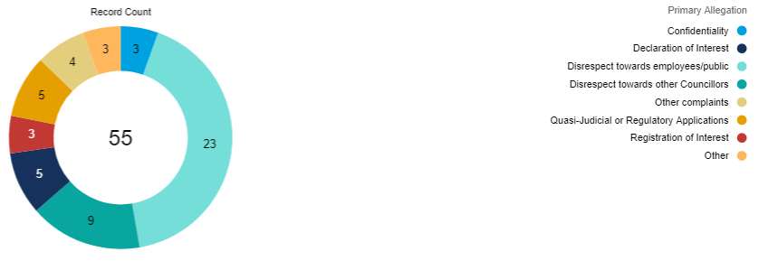
Members (M)
- The number of cases is as follows:
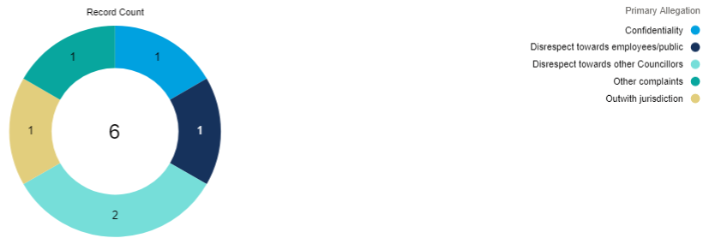

MSPs
- The number of cases is as follows:
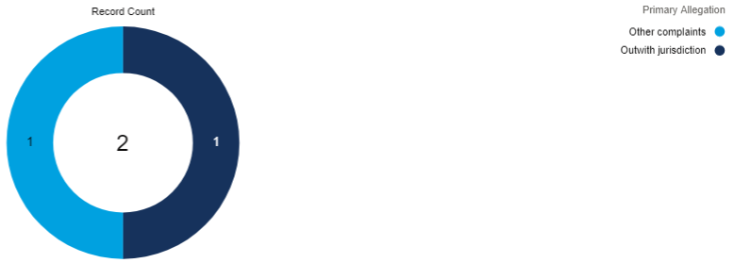
Lobbyists
- The number of cases is as follows:
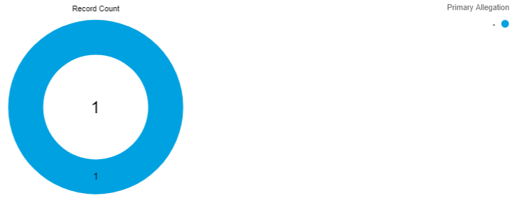

Appendix Three – Public Appointments Allocations

Appendix Four – Public Appointments contacts and enquiries

Enquiry about/for | No. on 2013 Code | No. on 2022 Code | Report about | No. on 2013 Code | No. on 2022 Code
Advice on the Code | 81 | 72 | PAA End of round | 31 | 7
Advice on good practice | 15 | 19 | Panel Chair End of round | 0 | 2
General work of office | 7 | 5 | Concern about appt round | 40 | 24
Other | 29 | 31 | Report an update on a round | 64 | 44
Exceptional circumstances | 20 | 10 | Report good practice | 24 | 41
Additional appointments | 5 | 0 | Other | 24 | 32
Extension request – NB | 8 | 6 | Report non-compliance | 10 | 3
Emergency appointment | 1 | 1
Panel membership | 1 | 2
Planning | 0 | 0
Succession planning | 0 | 0
Use of recruitment consultants | 0 | 0
General exception for applicant summaries | 0 | 0
Vacancy filled from a reserve list | 4 | 0
Other | 1 | 1
TOTALS | 152 | 137 |  | 193 | 153

