Making a complaint about a public appointment

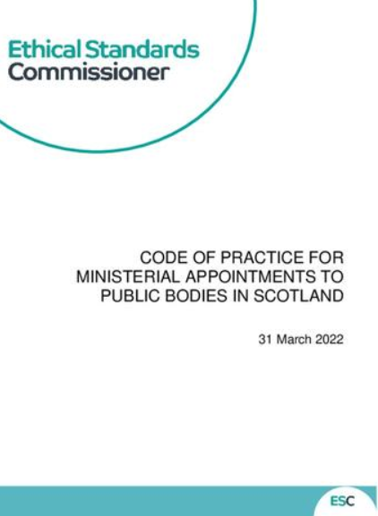






If you need this document in another format like large print, audio or Braille please contact us:

- call 0300 011 0550
- email: info@ethicalstandards.org.uk
- or do it online at www.ethicalstandards.org.uk/contact-us

Contents
 | Page
What does the Ethical Standards Commissioner do? | 3
What can you complain about? | 6
What can’t you complain about? | 7
When can I make a complaint? | 9
How do I make a complaint? | 10
How we investigate your complaint  What happens next? | 12  17

What does the Ethical Standards Commissioner do?

 | This document is about how to complain about a public appointment. If you would like to read about all the work that we do click here:  https://www.ethicalstandards.org.uk/publication/esc-purpose-values-and-strategic-objectives-2024-2028-easy-read
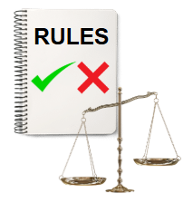 | Ethical standards are the rules about what is right and wrong.  Ethical standards help us know how to behave in a good way.  It means for example treating people the way you would like to be treated.
 | The Ethical Standards Commissioner was set up as part of some laws. One is called the Public Appointments and Public Bodies etc. (Scotland) Act 2003.
     | This law is about public appointments in Scotland.  A board and its members look at the work an organisation is doing and check it is working well and following the rules.  A public appointment is when a Scottish Government Minister appoints someone to the board of a public body.  A public body is an organisation that works for the Government and gives us public services. Examples of this include the police and health services.
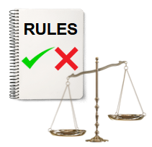 | The law says that public appointments must be regulated by the Commissioner.  Regulate means to make sure the work of something is done following the rules. The Commissioner sees if those rules are followed.
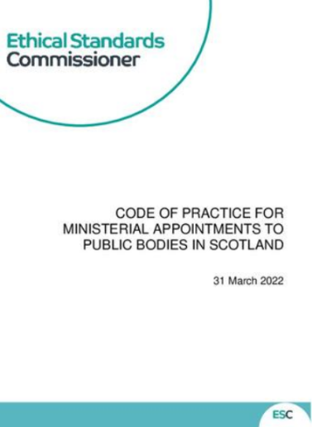 | We make a Code of Practice for Ministerial Appointments to Public Bodies in Scotland.  The Code of Practice is a set of rules about how to appoint someone to the board of a public body in a fair way.

What can you complain about?
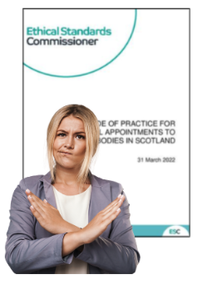 | You can complain if you think that someone has made a public appointment but not done what the Code of Practice says.
 | Your complaint must be about one of the public bodies that we regulate. You can find a list of these bodies here: https://www.ethicalstandards.org.uk/regulated-bodies
Your complaint must be about a breach of the Code of Practice.
A breach is when a rule has been broken.

 | If your complaint is not about either of these things then we cannot investigate it.

What can’t you complain about?
 | We can only check complaints about public appointments to a regulated body.
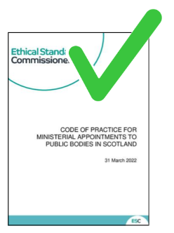 | Your complaint must be about the Code of Practice.
 | Under this process we cannot check complaints about things like:  - how a public body is run  - the conduct of people on public bodies.  Conduct means how someone behaves.
 | You can check how to complain about the conduct of board members here:  https://www.ethicalstandards.org.uk/publication/how-we-check-complaints-about-councillors-and-board-members-easy-read
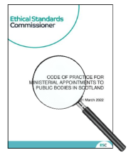 | You cannot complain because you do not like the person who was appointed. It has to be about a breach of the Code.
 | If we cannot help you with your complaint then we will tell you who might be able to help.

When can I make a complaint?
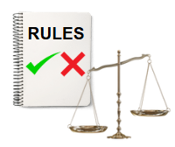 | Before you make a complaint you have to complain to the Scottish Government first.
 | This is so that they have a chance to respond.
 | If you have complained to the Scottish Government and are not happy with their response, you can then complain to us.

How do I make a complaint?

 | To make a complaint to us you can email, telephone or write to us.  Email: appointments@ethicalstandards.org.uk  Telephone: 0131 347 389  Our address is:  Ethical Standards Commissioner  Thistle House  91 Haymarket Terrace  Edinburgh  EH12 5SE
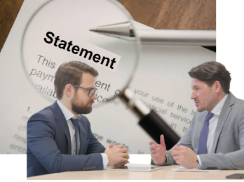 | When you are ready to make a complaint to us we will ask for a statement of complaint from you.  A statement of complaint is when someone writes down what went wrong.  We will talk to you about your statement of complaint by telephone or in writing and agree the final statement with you.
 | The statement will also let you know what the Commissioner can and cannot do once he investigates the complaint.
 | For example, where there has been a serious breach of the Code the Comissioner can tell the Scottish Parlaiment about it.
 | We try to agree on the statement of complaint within 20 working days.

How we investigate your complaint
 | We will write to the Scottish Government to let them know that we are investigating your complaint.
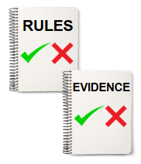   | We will:  - Give the Scottish Government your statement of complaint  - List anything that we need them to tell us  - Ask for copies of any information about your complaint  - Give them a deadline to respond  A deadline is the last day that something must be given to us. It is usually in 20 working days.
 | If we think the the complaint is very serious we will write to the head of the Scottish Government and the Permanent Secretary to tell them about it.  The permanent secretary is the person in charge of the Scottish Government.
 | Once the Scottish Government has given us any information we have asked for, we will investigate the complaint.
 | If the investigation takes more than 20 working days to finish we will tell you why.
 | We will keep you up to date on how long the investigation will take.
 | Once we have finished investigating your complaint, we will write to you and tell you what we have found.
 | We will also write to the Scottish Government to tell them what we have found.
 | This will include information about what the Commissioner will do about your complaint and why.
 | This might include making recommendations to the Scottish Government.  A recommendation is suggestion about what someone could or should do. It is usually said to make things better the next time.
   | Depending on the investigation, the Commissioner might make a report to the Scottish Parliament.  A report is a description of our investigation that is written down.
 | We will tell you if this is going to happen.
 | These reports are usually available for the public to read.
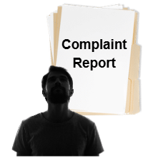 | We will not tell your name or any information about you in the public report.

What happens next?
 | If you are unhappy with how the Commissioner investigated your complaint then you can complain to us about it. You can’t complain about the Commissioner’s decision.
 | You can read more about how to complain about us here:  https://www.ethicalstandards.org.uk/investigation-process-ethical-standards-commissioner

