**Delivering Diversity**

*(#DD@10)*

MARCH 2019



Introduction

I am publishing this report as I approach the end of my five year term in office as Ethical Standards Commissioner for Scotland. Some of my statutory functions are set out in the [Public Appointments and Public Bodies etc. (Scotland) Act 2003](http://www.legislation.gov.uk/asp/2003/4/contents), which came into force in June 2004. The Act requires the Commissioner to publish and keep under review a code of practice for ministerial public appointments, to examine the methods and practices employed by the Scottish Ministers when making appointments, and to publish a strategy for ensuring that appointments are made in a manner which encourages equal opportunities.

This report records progress which has been made over the intervening 15 years in widening the diversity of appointments made to public bodies’ boards. It does so, particularly in relation to the equal opportunities strategy, entitled “Diversity Delivers”, which was published in September 2008 by the first Public Appointments Commissioner for Scotland, Karen Carlton. It also invites consideration of further steps which could lead towards achieving appointments that more closely reflect the diversity of the Scottish population.

It is to the credit of all involved in ministerial public appointments in Scotland over the intervening period that significant progress has been made, particularly in relation to gender diversity. That has been achieved despite the global financial crisis which coincided with launch of the strategy and has had continuing consequences for public finances. More recently, the demands of dealing with major constitutional issues have also impacted on the level of resource and attention available to address the challenges involved in achieving greater diversity amongst those appointed to the boards of public bodies.

Public bodies matter. They are responsible for the delivery of major public services; their combined budgets account for around £17 billion of Scottish Government spend. It therefore remains vital to ensure they continue to be well run. There is evidence from the private sector that appointment of a diverse range of able people to boards has a positive impact on the quality of the governance exercised by those boards and on the performance of the companies. Research is being conducted jointly by my office and by the Scottish Government into the difference which diversity is making to the governance of the boards of public bodies in Scotland.

I hope that this report will draw attention to the progress already made and assist my successor, the Scottish Ministers and their officials, who share the goal of achieving effective public boards which better reflect the diversity of Scottish society, to focus their attention and resources on the steps which may have the greatest impact.

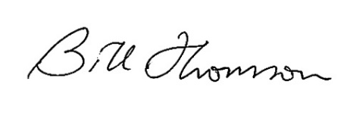

Bill Thomson

Ethical Standards Commissioner

25 March 2019

Aims, objectives and aspirations of the original 2008 Diversity Delivers Strategy

The strategy set the following targets for applications from people in currently underrepresented groups.

|  |  |
| --- | --- |
| **Group** | **Target** |
| Female | 40% |
| Disabled | 15% |
| BME (inclusive of non-visible minorities) | 8% |
| Age 49 and under | 40% |
| LGB (target based on a Stonewall Scotland estimate) | 6% |

The figures section at the end of this report provides information on the progress that has been made.

The practical recommendations included in the Diversity Delivers strategy fell into three distinct categories. These were:

**Awareness and Attraction** - A pool of applicants as diverse as the people of Scotland, aware of and attracted by the work of our public bodies and the opportunities to serve on their boards.

**AWARENESS AND ATTRACTION OBJECTIVES**

• Increase awareness amongst the general public of the role, value and diversity of public bodies.

• Increase awareness amongst the general public of the role of board members and the wide range of people we need to serve on the boards of public bodies.

• Attract interest, create enthusiasm and encourage action by the widest appropriate pool of potential applicants.

**Confidence and Capacity** - An appointments system that inspires confidence, increases capacity and embraces diversity, from the application process to the boardroom.

**CONFIDENCE AND CAPACITY OBJECTIVES**

• Ensure the public appointments process is encouraging, accessible and easy to navigate and that people know it is.

• Make sure the process is equipped to support a wider range of suitable applicants for each post.

• Make sure the people administering the process are equipped to do so effectively and efficiently.

**Education and Experience** - A programme of support for our future leaders, developing and providing opportunities for all to achieve their full potential and for Scotland to draw upon its brightest talent.

**EDUCATION AND EXPERIENCE OBJECTIVES**

• Provide relevant, effective and easily accessed development opportunities for the next generation of board members.

• Provide a pool of potential board members with the necessary expertise and experience, whose members reflect the diversity of the people of Scotland.

**Appreciation of Diversity throughout the Process**

As well as the specific recommendations provided under each of the categories, the strategy anticipated the mainstreaming of diversity and inclusion into the appointment process. These were to be integral to every stage in each appointment round. It was also anticipated that all selection panel members, body chairs and board members were to be trained regularly on how to manage equality issues and benefit from diversity. In the latter case, the topic was due to become part of chair and board member appraisals. The strategy anticipated monitoring of these changes by way of oversight by Public Appointments Assessors on individual appointment rounds, using thematic reviews and surveying applicants on their experience. As anticipated, my office has conducted a number of thematic reviews over the years, and regularly surveys applicants on their experiences. Reports relating to all this activity are available on the [website](https://www.ethicalstandards.org.uk/). I also have a team of 13 Assessors (who are now called Public Appointment Advisers) who provide oversight and good practice advice on a proportion of appointment rounds[1].

Changing Context of Public Life

A lot of changes have happened in the context of public life since the strategy was introduced in 2008. I mentioned in my introduction the global financial crisis which has impacted on financial resources in public life and more widely. In addition, the current political uncertainty surrounding Brexit has placed additional demands on increasingly stretched resources. I want to acknowledge, when seeking to understand any progress made against the strategy, that this has been achieved within a challenging landscape.

At the same time as these challenges are impacting on resources, there has been an increase in parliamentary and public interest in board governance. This interest and the current challenges that bodies face mean that getting the right people to govern their boards has never been more important. It could also be argued that understanding the needs of the board, and making changes to the appointment process to help to fulfil them, are vital if they are to succeed in a climate in which stretched demands for public resources are now the norm. Some of the interest may be attributable to the generally increased awareness of the public since 2008 due to the far higher availability and accessibility of information created by advanced use of the internet via social media. Awareness of and interest in public life in general provide a great opportunity to promote the improvements that have been made.

Advances in technology have created the means to communicate and engage with large audiences on a cost effective and low effort basis and there is a high expectation from a growing audience that these channels will be used.

Similarly, there is a greater cultural expectation for achieving diversity in all walks of life with movements such as #metoo and #blacklivesmatter sending out a strong message that equality should be fundamental to society as whole. The current administration also promotes and encourages equality and diversity as a key Scottish value. Most prominently, the First Minister’s well-publicised campaign for 50:50 by 2020 appears to have had a positive impact on applications from and appointments to women.

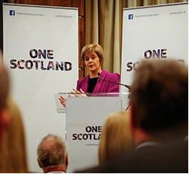



**First Minister speaking at University of Glasgow, Successful Women at Glasgow event, 4 February 2015 (One Scotland Website)**

**Progress Made**

There have been notable successes in relation to the **awareness and attraction** and the **confidence and capacity** strands of the strategy. A [full report](https://www.ethicalstandards.org.uk/publication/delivering-diversity-ten-years-full-report) setting out progress against individual recommendations is available on my [website](https://www.ethicalstandards.org.uk/). It is my intention in this report to provide an overview, alongside highlighting opportunities to build on the progress already achieved.

There have been significant improvements in particular towards the **Confidence and Capacity** Objectives.

A centre of expertise within the Scottish Government was established soon after the strategy was published in 2008, as per one of its recommendations, and has been in place since that time. It is currently called the Public Appointments Team although the title does not fully reflect the experience and expertise that its longer term members have built up. It delivers a consistent approach to the support provided to selection panels and sponsor teams. An outreach and development manager post was added to the team in 2015 to coordinate and develop that aspect of its activities.

The team effectively fulfils most of the functions anticipated by the original strategy recommendations, with the exception of those related to “learning lessons”. This would involve making evidence-based recommendations to panels about approaches that should attract and see the appointment of under-represented groups, leading to more diverse boards.

Further research has been undertaken by my office in the last few years (by way of [Thematic Review](https://www.ethicalstandards.org.uk/publication/2018-follow-thematic-review-operation-code)s) which has again demonstrated the improvements which would be achieved by making evidence-based recommendations to panels.

OPPORTUNITY 

Implement the recommendations detailed in the thematic review thereby helping panels to streamline the efforts needed to increase attraction and appointment of diverse applicants.

[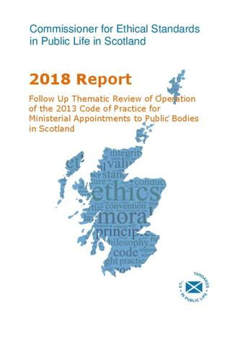](https://www.ethicalstandards.org.uk/publication/2018-follow-thematic-review-operation-code)

A board member core skills framework was produced with support from my office and does appear to have had a positive impact on both the transparency and effectiveness of the appointments process. The Scottish Government, alongside panels, continues to pilot new and innovative methods for attraction and assessment and this has led to the publication of many good practice case studies that are on the website.

OPPORTUNITY 

Make use of the good practice case studies available on my website to understand what has worked in other rounds.

[](https://www.ethicalstandards.org.uk/good-practice-case-studies)

**Good practice case studies**

Regular updates on new developments in equality and diversity, as recommended in the original strategy, are not provided as a matter of course to members of selection panels although the Public Appointments Advisers do receive regular updates from my office in this area and cascade such information during their early engagement with panels. Bias mitigation techniques are a good example of this. Some panel members / chairs have been involved in regular appointment rounds over a period of years and have developed a very good understanding and level of expertise in this area. There are also opportunities to share learning between these panel members and develop good practices across the piece.

OPPORTUNITY 

Build on the capacity and knowledge of panel members by providing regular, formal updates and training on equality and diversity. Share learning between panel members.

The strategy anticipated that every new board member would receive information about how diversity benefits board effectiveness as part of their induction. It also anticipated more specific ongoing training to board members and selection panels, such as disability equality training by people who are themselves disabled, to provide greater insight into the needs of disabled board members and applicants. Awareness of diversity and succession planning has become more embedded in the public appointments process. Activities which have helped to achieve this include:

* the Scottish Government has provided [succession planning guidance](https://www.gov.scot/publications/guidance-succession-planning-public-body-boards/), which makes specific reference to diversity
* all new board members are signposted to the Scottish Government’s updated [“On Board” guidance](https://www.gov.scot/publications/board-guide-members-statutory-boards/) and invited to a new member induction day. Diversity is a featured theme for every such induction day
* panel chairs who have never previously chaired a panel for regulated public appointments are offered a one to one briefing with a member of staff from my office. This makes specific reference to the importance of diversity to boards and to bias mitigation measures that should be adopted during appointment rounds
* most planning meetings for appointment rounds include unconscious bias mitigation as a standing agenda item
* The Scottish Government and my office piloted a formal training day for prospective independent panel members in 2018.

[](https://www.gov.scot/publications/guidance-succession-planning-public-body-boards/)[](https://www.gov.scot/publications/board-guide-members-statutory-boards/)

**Succession Planning Guidance and On Board Guidance by the Scottish Government (Scottish Government website)**

There is scope for more support to be given to the appointments process by boards themselves and I anticipate that the distribution of good practice case studies arising from the research into diversity in governance that my office is conducting in partnership with the Scottish Government will provide valuable advice in this area.

The strategy anticipated the provision of advice and support to body chairs also, on how to manage diversity on their boards in order to maximise the rewards that it can offer. The research project that is underway will highlight good practice, with case studies being published on my own and the Scottish Government’s websites.

Additionally, a proportion of chairs have taken part in a mentoring scheme to support potential chairs of the future. That has also provided a development opportunity for them due to peer to peer discussions on the skills required to be an effective chair, including the harnessing of a diversity of members. Chair networking events run by the Scottish Government also include updates on issues relating to equality and diversity.

OPPORTUNITY 

Continue the engagement with body chairs and boards themselves to encourage board support for the appointments process and increased understanding by boards as to how increased diversity supports good governance.

The strategy also anticipated that the person specification for chairs should be revised to include the ability to chair a diverse board. This recommendation was followed in 2016 when the core skills framework for chairs and board members was updated to include a relevant indicator under the heading of “leading the board”.

As per another recommendation, the Code was updated by my predecessor in 2013 and guidance on its application has been revised and subsequently refreshed by me in 2016 and 2019 to reflect and to reinforce what was recommended in the strategy.

[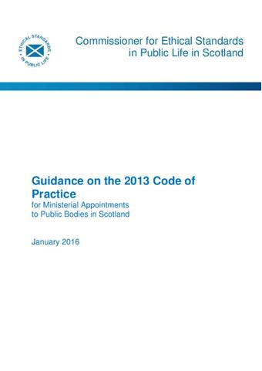](https://www.ethicalstandards.org.uk/publication/revised-guidance-application-2013-code-practice)[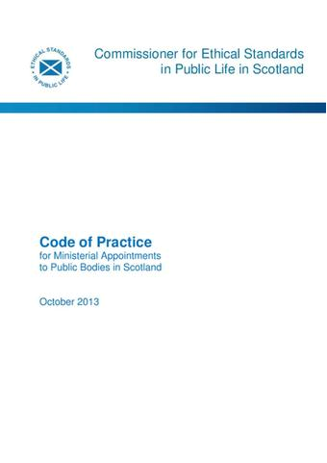](https://www.ethicalstandards.org.uk/publication/code-practice)



There has been some progress in the **Awareness and Attraction** category.

Whilst there has been no concerted media campaign to raise awareness of public appointments via Television advertising and/or advertorials to promote the topic, as was recommended in the original strategy, the Scottish Government has increasingly used social media to raise awareness, as have a proportion of boards, and has also run open “come on board” events to encourage interest from the general public. These involve chairs and board members as “role models” speaking about the role of board member and encouraging applications for forthcoming appointment rounds.

Alongside the First Minister’s campaign for 50:50 by 2020, it does appear to have had an impact on applications from and appointments to women in particular.

A pilot project run by the Scottish Government in around 2017 alongside Standard Life appeared to be successful but there has, to date, been limited engagement with other employers about the opportunities presented by public appointments for them and for their employees.

OPPORTUNITY 

Develop relationships with employers, highlighting the shared benefits of leadership skills which can be developed in undertaking public appointments.

It is recognised that in the current fiscal situation, events on a national level such as specific “public appointments fairs” as recommended in the original report are resource intensive and that the Scottish Government may be minded to consider alternative opportunities such as social media, podcasts or press interest in the subject matter to get the conversation into the public domain on a national level in a different way. Little progress has been seen in investigation of such alternative formats thus far.

OPPORTUNITY 

Continue to utilise and build on social media and other lower cost digital opportunities to raise awareness of and interest in public appointments.

There is a central website for all public appointments as was recommended in “diversity delivers”. Individuals are able to register their interest in public appointments via this site. A variety of information describing public appointments and help on how to apply is also hosted here. Its functionality is however, limited to this. It does not facilitate the matching of interested applicants to vacancies relevant to their skills and interests. It also doesn’t allow for the auto-completion of previously completed fields by prospective applicants. It does not direct people to other places where they can find out about development opportunities that might assist them towards obtaining a board position. Nor does it provide modular training, or equivalent, for people with an interest. All of these were recommended in the original strategy.

No “talent bank” (also recommended in the original strategy) has been established and neither have reciprocal links with organisations that might have established their own. There are therefore numerous opportunities for development in the technological advancement of public opportunities sphere which many applicants will more and more expect to see in a digitally advanced age.

OPPORTUNITY 

Develop [appointed for Scotland](http://www.appointed-for-scotland.org/) (the hub website) to provide better interactive opportunities for applicants commensurate with today’s technologies. Provide facilities such as auto-completion of previously completed fields, development opportunities, training and possibly a talent bank with reciprocal links with other organisations.

Positively, a proportion of materials provided to prospective applicants are increasingly more attractive, based on the brand of the body. Application packs invariably include a welcoming letter from the chair of the body. I have been heartened to see this move to more attractive materials during my time as Commissioner, but disappointed that there has not been more progress with materials provided to prospective applicants with disabilities. Applicant information packs are not explicit about the support that people can expect, not just with the appointments process but in the event that they are appointed. Likewise, research into more flexible arrangements for attendance at meetings and into the impact of taking up an appointment on benefits for disabled people has not been conducted.

OPPORTUNITY 

Develop an action plan to address the specific needs of disabled applicants.

[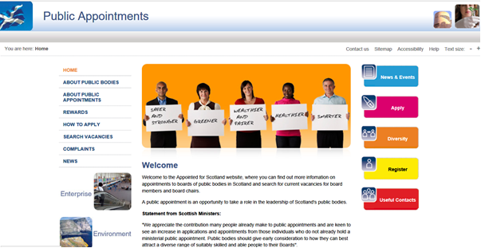](http://www.appointed-for-scotland.org/)

**Appointed for Scotland Homepage**

There has been least progress in the **Education and Experience** category and there are therefore commensurate opportunities to explore and implement appropriate recommendations which were suggested there.

The strategy recommended running an education programme for members of the public with an interest in taking up board roles. The first Commissioner in Scotland piloted a successful project in 2009/10 but that did not lead to the establishment of an ongoing equivalent by the Scottish Government. The Scottish Government currently runs “Come on board” awareness raising events (as described above under awareness and attraction). These appear to be popular and are welcomed by members of the public who attend them. They could therefore provide a means to extend from awareness raising to more detailed help and education for potential applicants, or to gather information from attendees as to what further education they might need.

OPPORTUNITY 

Build on the success of “Come on board” events to become education events as well as awareness raising.

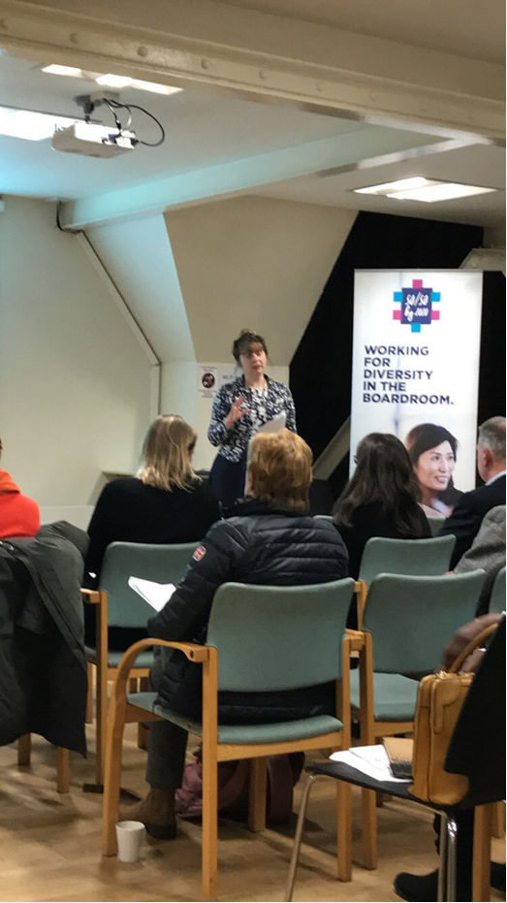

**Come on Board - December 2018**

Another recommendation in the original strategy as for an ongoing programme of workshops to be run to educate people about the role and work of boards and their members and to give people the skills they needed to navigate the appointments process. Workshops such as these have been run over the period since the strategy was published but they have not been sufficiently focused on the groups that are currently underrepresented. There is scope for such positive action to now take priority, particularly for people with disabilities.

OPPORTUNITY 

Include workshops for disabled applicants in the disability action plan highlighted as an opportunity under attraction and awareness.

Also included in the education and experience section of the strategy were recommendations for the identification, encouragement and development of talent and potential at the level just below current boards, such as on committees. These were linked with a recommendation for the establishment of board training/apprenticeship positions. There may be a role for boards in this activity and for the Scottish Government in the coordination and signposting of development roles.

OPPORTUNITY 

Boards could consider whether they could provide training or apprenticeships to potential applicants.

The strategy also anticipated a central information hub website where people with an interest could go to find out about development opportunities. There is still an opportunity for the Scottish Government to consider how they might develop this, – for example by establishing links with the voluntary sector and/or the private sector (via [step on board](https://trustees-unlimited.co.uk/step-board) for example). This would allow potential applicants the opportunity to develop skills, knowledge and experience which could be helpful to future applications to public body board positions.

OPPORTUNITY 

Establish links with voluntary and/ or private sector organisations to develop opportunities for potential applicants to develop skills, knowledge and experience.

The final recommendation in this section of the strategy concerned the development of the chairs of the future. I am pleased to note that this work began in 2017 with a pilot mentoring programme, supported by my office. It has proved to be successful and the Scottish Government plans to run it on a continuing basis.

**The Figures**

**Applications and appointments**

This table shows the application and appointment figures for 2007/08, 2010/11, when Diversity Delivers Three Years On was published, and 2017.

|  |  |  |  |  |  |
| --- | --- | --- | --- | --- | --- |
| Under-represented group | Year | Target | Applied | Appointed | Scottish Population* |
| Female | 2007/08 |  | 33.8% | 29.0% |  |
|  | 2010/11 |  | 34.2% | 37.1% |  |
|  | 2017 | 40% | 39.5% | 52.8% | 51.5% |
| Disabled | 2007/08 |  | 13.6% | 1.1% |  |
|  | 2010/11 |  | 12.4% | 7.8% |  |
|  | 2017 | 15% | 11.0% | 6.5% | 19.6% |
| Black and minority ethnic** | 2007/08 |  | 8.0% | 2.8% |  |
|  | 2010/11 |  | 3.9% | 3.4% |  |
|  | 2017 | 8% | 7.0% | ^ | 4.0% |
| Aged 49 and under | 2007/08 |  | 27.5% (50 & under) | 84% (55 & under) |  |
|  | 2010/11 |  | 21.4% | 23.3% |  |
|  | 2017 | 40% | 27.1% | 29.6% | 54.3%† |
| Lesbian, gay, bisexual or other sexuality | 2007/08 |  | Unknown | Unknown |  |
|  | 2010/11 |  | 2.6% | 6.0% |  |
|  | 2017 | 6% | 4.6% | 4.6% | 6.0%†† |

|  |  |
| --- | --- |
| Key: |  |
| ^ | Values for fewer than five have been supressed to decrease the risk of disclosure of information about individuals. |
| * | Unless otherwise stated, all population figures are extracted from 2011 census data |
| ** | The target for the BME population is inclusive of people from non-visible minority groups. |
| † | Scottish population aged 18 to 49 as a percentage of whole population 18 and over |
| †† | Estimated based on information from Stonewall Scotland website |

**Board profile**

|  |  |  |  |  |  |  |  |
| --- | --- | --- | --- | --- | --- | --- | --- |
| **Target Group** |  |  | **All board members**  **(inclusive of chairs)** | | | | **Scottish Population (2011 Census)** |
|  | **2017/18** | **2016/17** | **2015/16** | **2014/15** | **2013/14** | **2004/05** |  |
| Female | 45.6% | 45.1% | 42.0% | 38.4% | 35.0% | 34.5% | 51.5% |
| Disabled | 7.9% | 9.2% | 11.8% | 15.3% | 13.1% | 2.4% | 19.6% |
| Black and minority ethnic | 3.2% | 3.6% | 3.5% | 2.9% | 2.2% | 2.8% | 4.0% |

**Application and Appointment Charts Covering the Period Since Diversity Delivers was Published**

The following charts show applications from and appointments to the target groups identified in Diversity Delivers. The target for applications from each group is also included for ease of reference.

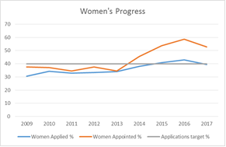 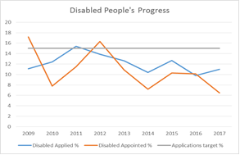

Note - The Scottish Government advised in 2012/13 that the statistics were not valid due to a systems error

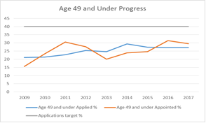 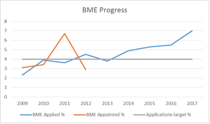

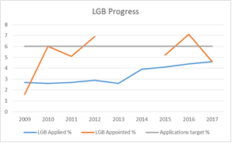

1. Further information on the extent of oversight provided can be found in my annual reports on my [website](https://www.ethicalstandards.org.uk/publications).