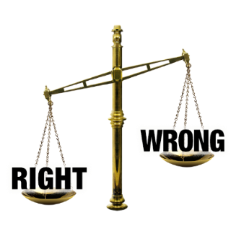
Ethical Standards Commissioner

Our plan for our work from 2021-2024

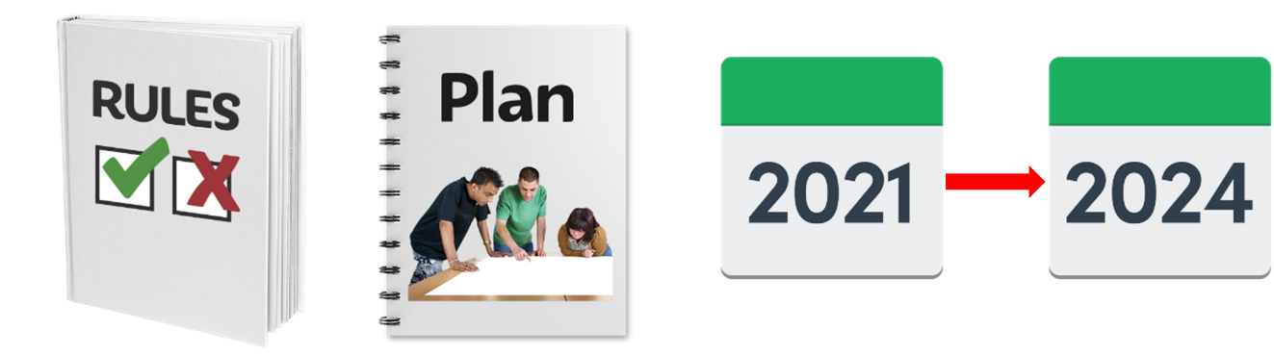

If you need this document in another format like large print, audio or Braille please contact us:

- call 0300 011 0550
- email: info@ethicalstandards.org.uk
- or do it online at: www.ethicalstandards.org.uk/contact-us

Copyright images © Photosymbols. Prepared by Disability Equality Scotland

A message from Ian Bruce the Acting Ethical Standards Commissioner
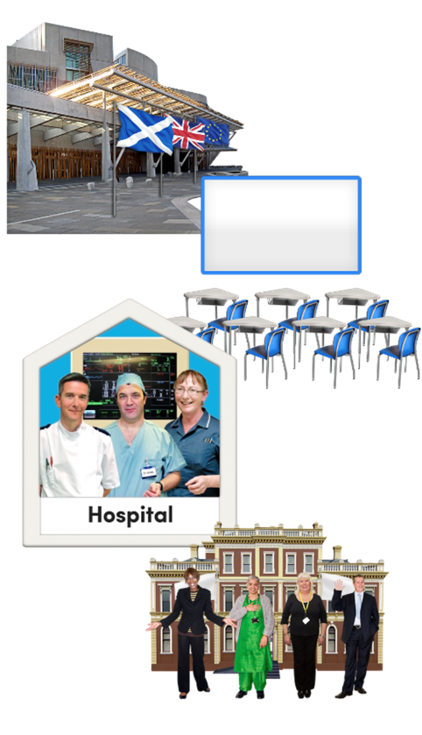  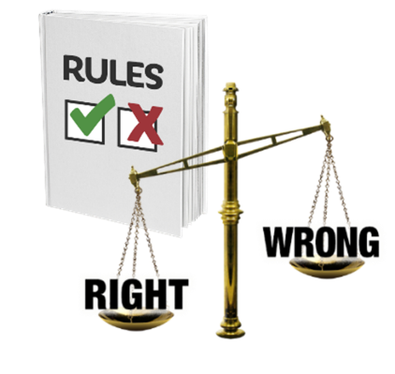 | “Ethical standards are the rules about what is right and wrong.  It means for example treating people the way you would like to be treated.  This plan has come out earlier than planned because:  - auditors had a review of our work  Auditors are people who check the work of an organisation.  A review is when something is looked at to see if it is working well and what needs to change.  - we got a lot more complaints about the conduct of people who work in public services.  Conduct is the way someone behaves when they are working.  Public services are services we all use like the Scottish Government, schools, hospitals and councils.
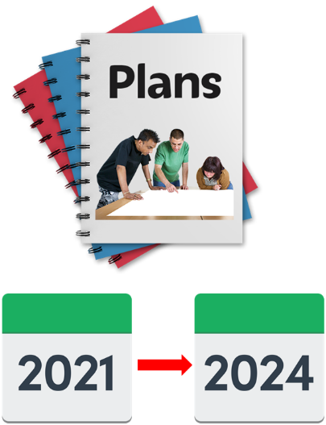 | I thank the auditors for their work.  Most of what they want to see happen is in this plan and the Biennial business plan.  The biennial business plan tells people what we will do in the next 3 years and how we will do it.
I want to say thank you to all the people and organisations that told us what they thought about the first version of this plan.

Their views have helped us make this plan better.”

What does the Ethical Standards Commissioner do?
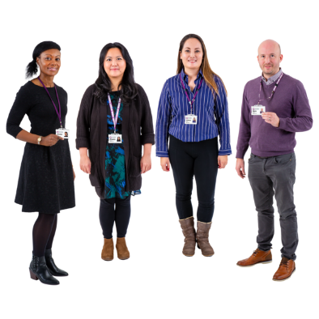  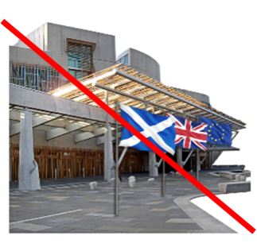 | The Commissioner and their team are independent.  Independent means they do not work for the Scottish Parliament or Scottish Government.  The work the Commissioner does links with Scottish Government plans to make public services better.
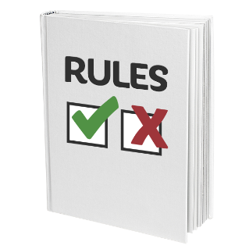  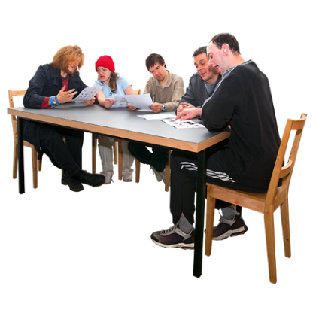  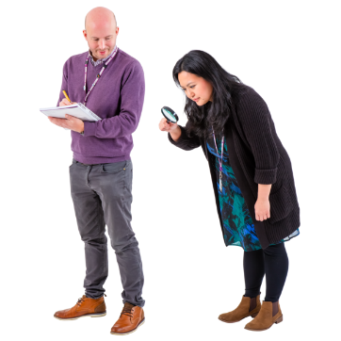 | A complaint is when a person says or writes that they are not happy about something.  - We investigate complaints about the conduct of:  - Members of the Scottish Parliament (MSPs)  - local councillors  - and board members of public bodies.  These organisations follow a Code of Conduct.  A Code of Conduct is a set of rules that say how people should behave when they are at work.  Board members look at the work an organisation is doing and check it is working well.  Public bodies are organisations that work for the Government and give us public services.
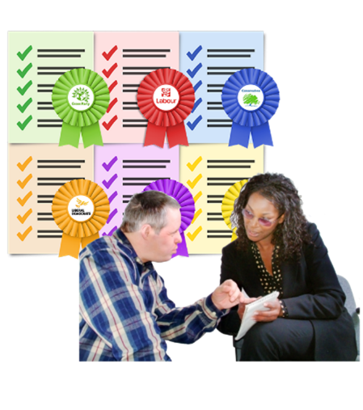 | - We investigate lobbyists who have not put their name on a Government list.  A lobbyist is a person or group who tries to get an MSP to support a policy or campaign.
- We investigate information from whistle-blowers.
A whistle-blower is a person who reports information about an organisation doing things that are against the law or are not safe.

 | - We report honestly and clearly about what we find.
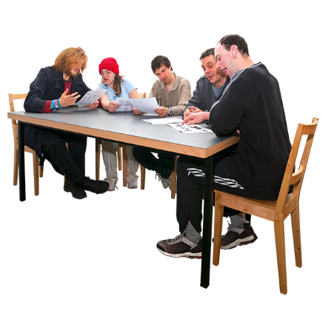 | - We check how Scottish Ministers make public appointments.  A public appointment is when a Scottish Government Minister appoints someone to the board of a public body.  We check that people get these roles fairly.
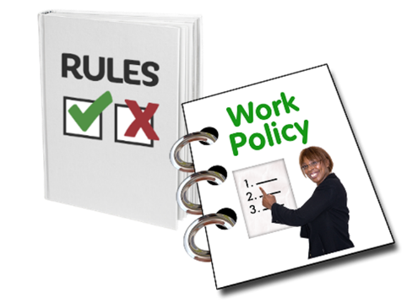 | - We make a Code of Practice for Ministerial Appointments to Public Bodies in Scotland.  The Code of Practice is a set of rules about how to appoint someone to the board of a public body in a fair way.  We want to make changes to this Code to make it better.
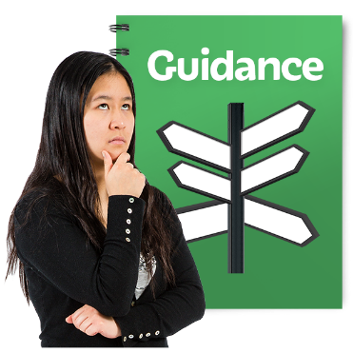 | - We give guidance and support to Scottish Ministers and boards to make sure they treat everyone who applies to be a board member fairly and boards are diverse.  Diverse means having a mix of different kinds of people:  - men and women  - young and old people  - people of different ethnic backgrounds  - people from both poor and more wealthy backgrounds  - disabled and non-disabled people.
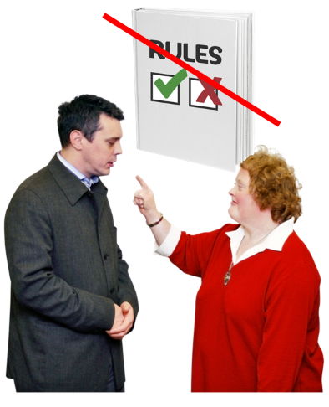 | - We investigate complaints when people or organisations have not followed the rules in the Code of Practice.  We tell the Scottish Parliament when this happens.

What we believe in
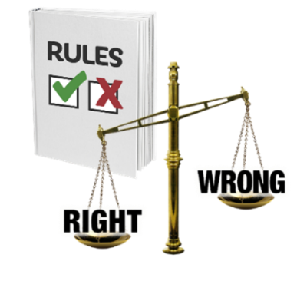 | - We will do all our work in an ethical way following the rules of what is right and wrong.
 | - We will spend money in a good way.
 | - We will be honest and open about what we do.
- We will treat every individual and organisation that contacts us with kindness and respect so they can trust us.

We will treat everyone fairly.
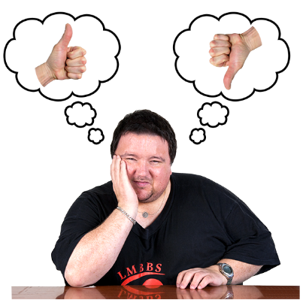 | - We will tell people when we get things wrong.  We will show what we have learned and make our work better.

What do we want to achieve?

Make sure we have the staff, money and materials to do our work
- The people that work in our organisation are very important.
We support them to feel comfortable, healthy and happy and to be proud of their work.

Have a good complaints system
- We will have a complaints system that:
  - works well
  - helps us to learn
  - makes sure people who work in public service have high standards.
- We will ask organisations we work with about how we deal with complaints.

We will make changes because we listen to what people tell us.

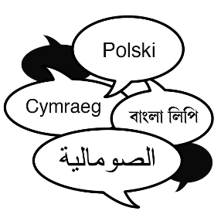 | - We will make a new document about how we do investigations.  We will make parts of it in Easy Read, British Sign Language and other languages.
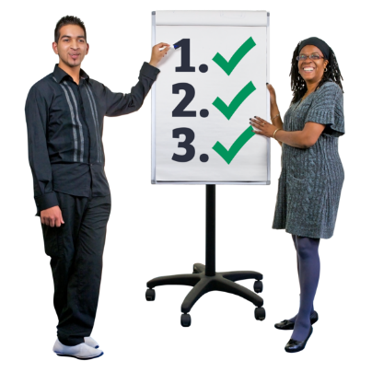 | - We will make sure staff are trained to do their jobs well and know:  - how to use the new Code of Practice and Codes of Conduct  - how to use the Public Sector Equality Duty in their work.
 | The Public Sector Equality Duty means the Scottish Government and public bodies must do work that supports equality and treats everyone fairly.
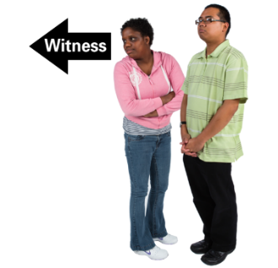  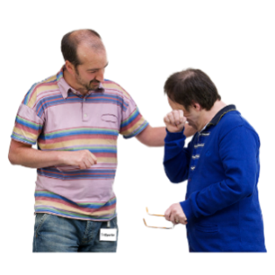 | - When we investigate complaints about bullying and harassment we will show there must be good support for:  - people making a complaint  - the person being complained about  - witnesses – people who have seen something happen.

Tell people about our rules and how do our work
 | - We will make sure our organisation has new and better rules about the way we work.
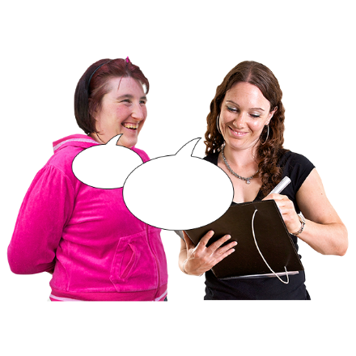 | - We will have ways to check our work.  This will include surveys of people we work with.  We will use the information they give us to make our work fairer and better.
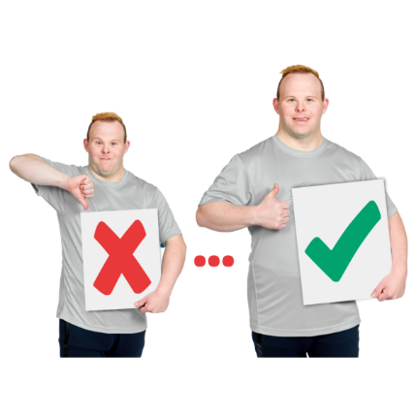 | - We will tell people about how the new Code of Practice has changed the appointments process.  We will tell people about:  - things that work well  - new ways of working  - what we have learned  - what work could be better.
- We will work with:
  - the Scottish Government
  - the Scottish Parliament
  - the Standards Commission for Scotland
  - and stakeholders

to tell people about good ways of working and make sure organisations learn from our investigations and change things.
Stakeholders are people or organisations who support our work.

We will help to make sure boards are diverse and look like the communities they work with
 | - We will make sure the rules give us diverse boards that work well.
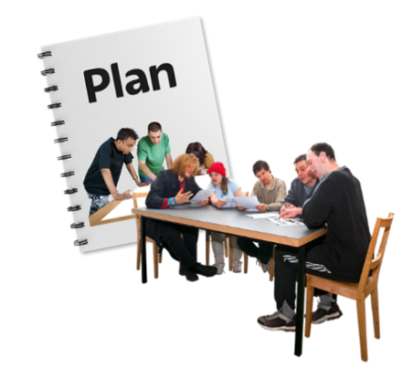 | - We will look for support to make changes to Diversity Delivers.  Diversity Delivers is a document about how boards can have a mix of different kinds of people.
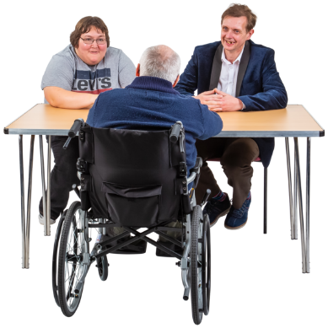 | - We will listen to what our stakeholders think before we make a new Code of Practice for board appointments.
 | - We will give guidance, training and support to everyone involved in appointing people to boards to make sure they know how to use the new Code.

How we will tell people how well work is going:
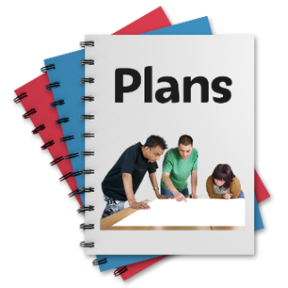  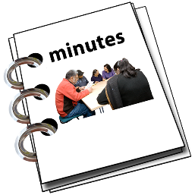 | We do this:  - in our Annual Report and Biennial Business Plan  - by putting the minutes of Senior Management Team meetings on our website  - using social media.
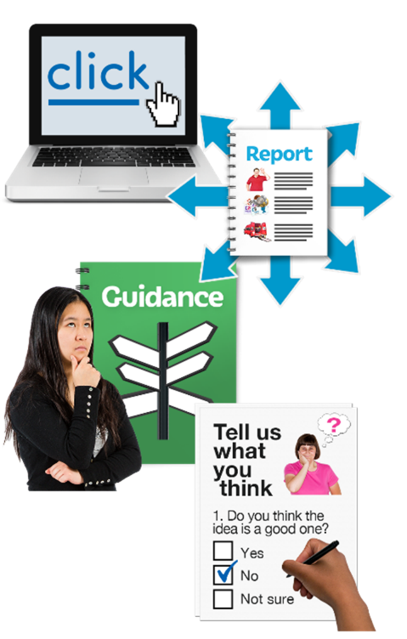 | Our website has:  - reports about our work for Scottish Parliament Committees  - information needed for laws and national guidance  - information about what works well  - results of information we get from other organisations using surveys and other methods.
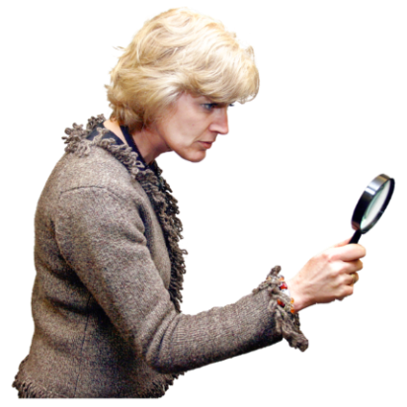 | Our work is checked by:  - Scottish Parliament Committees  - The Standards Commission for Scotland  - The Scottish Public Service Ombudsman
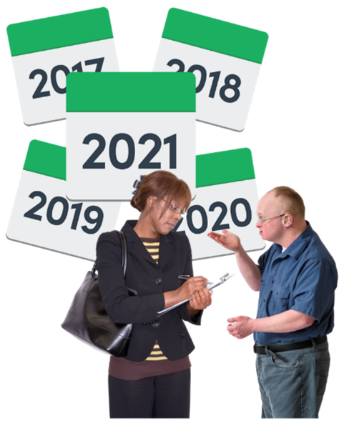 | There will be more work for us because the changes to the Code of Conduct for MSPs mean people can complain about things that have happened at any time in the past.
We worked with the Scottish Government and the Standards Commission for Scotland on the new Codes.
The Standards Commission makes decisions about the complaints that we pass on to them.

What will the plan cost?
It will cost £1,051,000 in 2021/22.
It will cost £1,145,000 in 2022/23.
It will cost £1,153,000 in 2023/24.

What work will be done when?
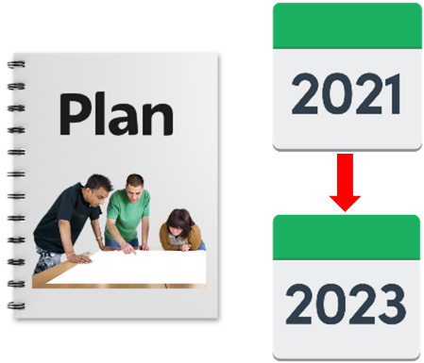 | Dates are in our Biennial Business Plan 2021-2023.

Copyright images © Photosymbols. Prepared by Disability Equality Scotland

