SUPPORT LEAFLET

Emergency Helplines:
NHS Lothian Mental Health Assessment Service - 0131 537 6000
NHS 24 - 111
Samaritans – 116 123
Edinburgh Crisis Centre - 0808 801 0414 (Text – 07974429075, Email - crisis@edinburghcrisiscentre.org.uk)
Breathing Space - 0800 83 85 87
https://www.nhs.uk/conditions/stress-anxiety-depression/mental-health-helplines/

Local Support:
NHS Lothian Mental Health Assessment Service - 0131 537 6000
https://services.nhslothian.scot/MentalHealthAssessmentService/Pages/default.aspx

NHS Lothian Mental Health Information Station (approx. 10 minutes walk from Thistle House)
https://services.nhslothian.scot/mentalhealthinformationstation/Pages/default.aspx

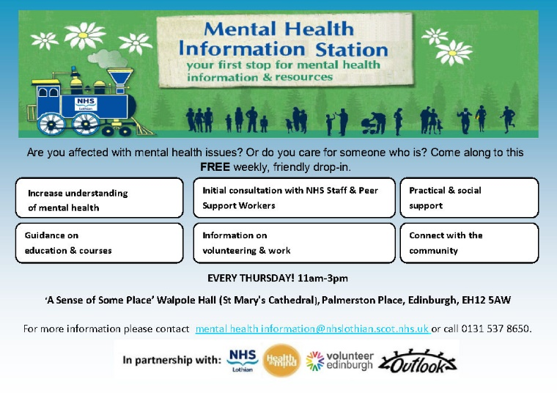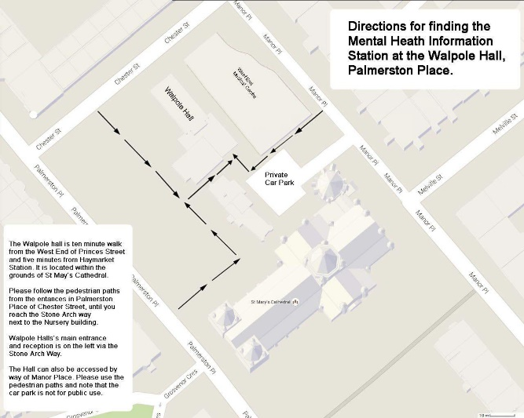
NHS Fife - https://fifedirect.org.uk/nhs/index.cfm?fuseaction=nhs.pagedisplay&p2sid=F49DA9DD-DEBB-8700-41D079FA686C33D1&themeid=3B984BF2-65BF-00F7-D42941481355468F
NHS Greater Glasgow and Clyde - http://www.headsup.scot/services-and-support/what-support-is-there-for-you/

Edinburgh Crisis Centre - http://www.edinburghcrisiscentre.org.uk/wordpress/index.php/help-now/
Edspace - https://edspace.org.uk/
Scottish Association for Mental Health (SAMH) - https://www.samh.org.uk/
Health in Mind - https://www.health-in-mind.org.uk/
Support in mind Scotland (support for carers as well as those suffering) - https://www.supportinmindscotland.org.uk/

On line information and support:
https://www.nhs.uk/conditions/stress-anxiety-depression/
https://www.nhs.uk/apps-library/category/mental-health/
https://services.nhslothian.scot/stresscontrol/Pages/Helpful-Resources.aspx
https://breathingspace.scot/
www.moodcafe.co.uk
https://www.mind.org.uk/information-support/tips-for-everyday-living/online-mental-health/online-mental-health-tools/
https://www.cope-scotland.org/

Other:
Scotland’s professional body for counselling and psychotherapy (including a directory of registered therapists) - http://www.cosca.org.uk/

